Code that classifies the dataset divided into 80-20 ratios with the BERT method;

#80-20 oranda bölünmüş dataseti BERT metodu ile sınıflandıran kod;

import tensorflow as tf
from transformers import TFBertForSequenceClassification, BertTokenizer
from sklearn.model_selection import train_test_split
from sklearn.preprocessing import LabelEncoder
from sklearn.metrics import classification_report, confusion_matrix
import pandas as pd
import numpy as np
import re
import matplotlib.pyplot as plt
import seaborn as sns

# Adım 1: Veriyi temizleyen fonksiyon
def clean_text(text):
text = re.sub(r'[^\w\s]', '', text) # Noktalama işaretlerini kaldır
text = re.sub(r'\s+', ' ', text) # Çoklu boşlukları tek boşlukla değiştir
text = text.lower() # Küçük harfe çevir
return text

# Adım 2: Veriyi bölme
def split_data(data):
X = data['text']
y = data['category']
return train_test_split(X, y, test_size=0.8, random_state=42)

# Adım 3: BERT modelini oluşturma
def create_bert_model(num_labels):
model = TFBertForSequenceClassification.from_pretrained(
"bert-base-uncased",
num_labels=num_labels
)
return model

# Learning Rate Scheduler
def lr_scheduler():
return tf.keras.callbacks.ReduceLROnPlateau(
monitor='val_loss',
factor=0.5,
patience=2,
min_lr=1e-6,
verbose=1
)

# Adım 4: BERT modelini eğitme
def train_bert_model(model, train_data, val_data, epochs, learning_rate):
optimizer = tf.keras.optimizers.Adam(learning_rate=learning_rate)
loss_fn = tf.keras.losses.SparseCategoricalCrossentropy(from_logits=True)
metrics = ["accuracy"]

model.compile(optimizer=optimizer, loss=loss_fn, metrics=metrics)

scheduler = lr_scheduler()

early_stopping = tf.keras.callbacks.EarlyStopping(
monitor='val_loss',
patience=2,
restore_best_weights=True,
verbose=1
)

model.fit(
train_data,
validation_data=val_data,
epochs=epochs,
callbacks=[scheduler, early_stopping],
verbose=1
)
return model

# Adım 5: Modeli değerlendirme ve sonuçları raporlama + Confusion Matrix
def evaluate_model(model, val_data, val_labels_encoded, label_encoder):
predictions = model.predict(val_data)["logits"]
predicted_labels_encoded = np.argmax(predictions, axis=1)

decoded_labels = label_encoder.inverse_transform(val_labels_encoded)
decoded_predictions = label_encoder.inverse_transform(predicted_labels_encoded)

report = classification_report(decoded_labels, decoded_predictions, target_names=label_encoder.classes_)
print("Sınıflandırma Raporu (BERT):")
print(report)

# Sınıf başına düşen eleman sayısını yazdırma
print("\nSınıf Başına Düşen Eleman Sayısı (Test Seti):")
unique_labels, counts = np.unique(decoded_labels, return_counts=True)
for label, count in zip(unique_labels, counts):
print(f"{label:<40} {count}")

# Confusion Matrix
cm = confusion_matrix(decoded_labels, decoded_predictions, labels=label_encoder.classes_)
cm_df = pd.DataFrame(cm, index=label_encoder.classes_, columns=label_encoder.classes_)

plt.figure(figsize=(12, 10))
sns.heatmap(cm_df, annot=True, fmt='d', cmap='Blues', cbar=False, linewidths=0.5)

plt.title("Confusion Matrix - BERT", fontsize=16)
plt.xlabel("Tahmin Edilen Etiket", fontsize=12)
plt.ylabel("Gerçek Etiket", fontsize=12)

# X ekseni etiketlerini düzelt
plt.xticks(ticks=np.arange(len(label_encoder.classes_)) + 0.5, # merkezleme
labels=label_encoder.classes_,
rotation=45,
ha='right')

# Y ekseni etiketleri
plt.yticks(ticks=np.arange(len(label_encoder.classes_)) + 0.5, # merkezleme
labels=label_encoder.classes_,
rotation=0)

plt.tight_layout()
plt.show()

# Ana program
if __name__ == "__main__":
# Veri setini yükleme
file_path = '/content/drive/MyDrive/Text Classification Tez Çalışması/inputs for final task/bbc_data_Format_151K.xlsx'
data = pd.read_excel(file_path)

# Veriyi temizleme
data['text'] = data['text'].apply(clean_text)

# Kategori etiketlerini kodlama
label_encoder = LabelEncoder()
data['category_encoded'] = label_encoder.fit_transform(data['category'])

# Veriyi bölme
X_train, X_test, y_train_encoded, y_test_encoded, y_train_labels, y_test_labels = train_test_split(
data['text'], data['category_encoded'], data['category'], test_size=0.8, random_state=42
)

# Tokenizer ve maksimum uzunluk
tokenizer = BertTokenizer.from_pretrained("bert-base-uncased")
max_length = 256

train_encodings = tokenizer(list(X_train), truncation=True, padding='max_length', max_length=max_length, return_tensors="tf")
test_encodings = tokenizer(list(X_test), truncation=True, padding='max_length', max_length=max_length, return_tensors="tf")

# TF Dataset oluşturma
train_dataset = tf.data.Dataset.from_tensor_slices(({
"input_ids": train_encodings["input_ids"],
"attention_mask": train_encodings["attention_mask"]
}, y_train_encoded)).batch(32)

test_dataset = tf.data.Dataset.from_tensor_slices(({
"input_ids": test_encodings["input_ids"],
"attention_mask": test_encodings["attention_mask"]
}, y_test_encoded)).batch(32)

# Model oluştur
bert_model = create_bert_model(num_labels=len(label_encoder.classes_))

# Eğitimi başlat
trained_model = train_bert_model(
model=bert_model,
train_data=train_dataset,
val_data=test_dataset,
epochs=8,
learning_rate=1e-5
)

# Değerlendir
evaluate_model(
trained_model,
{"input_ids": test_encodings["input_ids"], "attention_mask": test_encodings["attention_mask"]},
y_test_encoded,
label_encoder
)

All PyTorch model weights were used when initializing TFBertForSequenceClassification.

Some weights or buffers of the TF 2.0 model TFBertForSequenceClassification were not initialized from the PyTorch model and are newly initialized: ['classifier.weight', 'classifier.bias']
You should probably TRAIN this model on a down-stream task to be able to use it for predictions and inference.
Epoch 1/8
749/749 [==============================] - 396s 478ms/step - loss: 0.9093 - accuracy: 0.7563 - val_loss: 0.5047 - val_accuracy: 0.8401 - lr: 1.0000e-05
Epoch 2/8
749/749 [==============================] - 343s 459ms/step - loss: 0.4199 - accuracy: 0.8684 - val_loss: 0.4314 - val_accuracy: 0.8616 - lr: 1.0000e-05
Epoch 3/8
749/749 [==============================] - 344s 459ms/step - loss: 0.3088 - accuracy: 0.9058 - val_loss: 0.4187 - val_accuracy: 0.8693 - lr: 1.0000e-05
Epoch 4/8
749/749 [==============================] - 343s 459ms/step - loss: 0.2252 - accuracy: 0.9332 - val_loss: 0.4511 - val_accuracy: 0.8646 - lr: 1.0000e-05
Epoch 5/8
749/749 [==============================] - ETA: 0s - loss: 0.1642 - accuracy: 0.9532
Epoch 5: ReduceLROnPlateau reducing learning rate to 4.999999873689376e-06.
749/749 [==============================] - 343s 459ms/step - loss: 0.1642 - accuracy: 0.9532 - val_loss: 0.4804 - val_accuracy: 0.8650 - lr: 1.0000e-05
Epoch 5: early stopping
Restoring model weights from the end of the best epoch: 3.
2995/2995 [==============================] - 208s 68ms/step
Sınıflandırma Raporu (BERT):
precision recall f1-score support

Astronomy & Astrophysics 0.92 0.95 0.93 8550
Biology 0.67 0.66 0.66 7199
Chemistry 0.87 0.87 0.87 8177
Computer Science, Artificial Intelligence 0.93 0.92 0.93 8623
Economics & Business 0.90 0.96 0.93 7440
Environmental Science 0.84 0.84 0.84 8476
Geography 0.90 0.86 0.88 9347
Materials Science, Coatings & Films 0.93 0.93 0.93 8285
Medicine, Research & Experimental 0.78 0.68 0.73 7121
Neurosciences 0.77 0.85 0.81 7327
music 0.99 0.99 0.99 7500
physics 0.89 0.88 0.89 7779

accuracy 0.87 95824
macro avg 0.87 0.87 0.87 95824
weighted avg 0.87 0.87 0.87 95824

Sınıf Başına Düşen Eleman Sayısı (Test Seti):
Astronomy & Astrophysics 8550
Biology 7199
Chemistry 8177
Computer Science, Artificial Intelligence 8623
Economics & Business 7440
Environmental Science 8476
Geography 9347
Materials Science, Coatings & Films 8285
Medicine, Research & Experimental 7121
Neurosciences 7327
music 7500
physics 7779
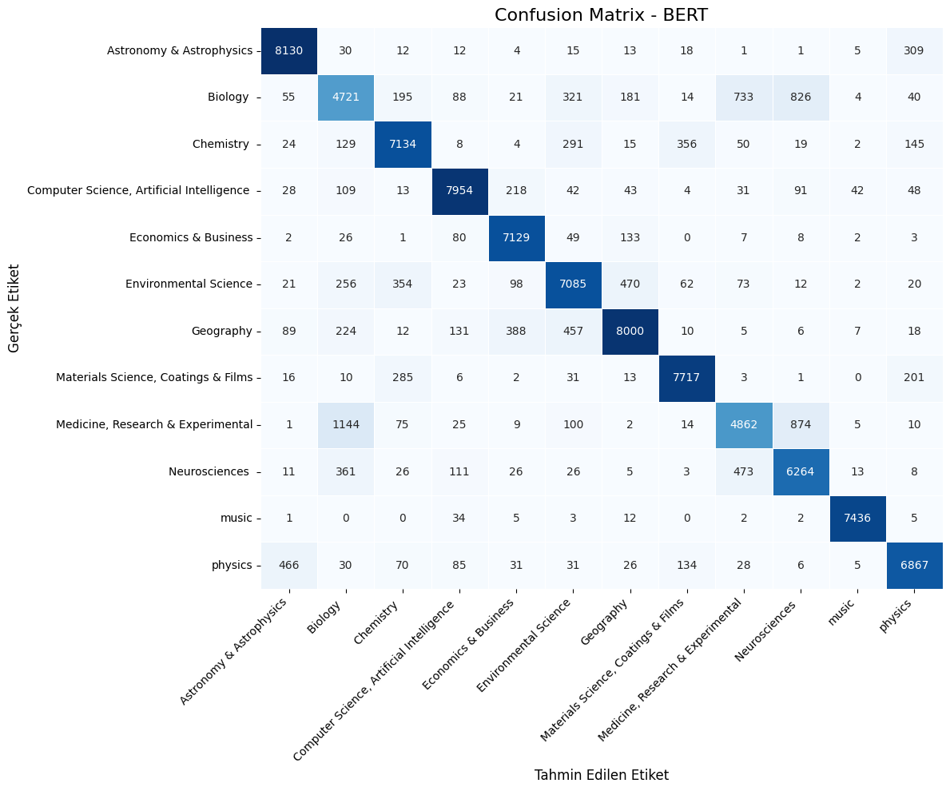

The Version of the Bert Code with a GPU Measurement and Time Counter Added, the Results of Which are Given in the Article :

#çalışan bert koduna sadece gpu ölçüm ve süre sayacı eklenmiş hali.

import tensorflow as tf
from transformers import TFBertForSequenceClassification, BertTokenizer
from sklearn.model_selection import train_test_split
from sklearn.preprocessing import LabelEncoder
from sklearn.metrics import classification_report, confusion_matrix
import pandas as pd
import numpy as np
import re
import matplotlib.pyplot as plt
import seaborn as sns
import time # Süre ölçümü için eklendi
import psutil # CPU/RAM ölçümü için eklendi
import platform # İşlemci bilgisi için eklendi
import GPUtil # GPU ölçümü için eklendi (eğer yüklüyse)

# --- PERFORMANS İZLEME FONKSİYONLARI (Minimum değişikliklerle eklendi) ---
def get_system_metrics():
"""Anlık CPU, RAM ve GPU kullanım metriklerini döndürür."""
cpu_percent = psutil.cpu_percent(interval=None) # Anlık CPU kullanımı
ram_info = psutil.virtual_memory()
ram_used_gb = round(ram_info.used / (1024**3), 2)
ram_total_gb = round(ram_info.total / (1024**3), 2)

gpu_info = []
try:
gpus = GPUtil.getGPUs()
if gpus:
for gpu in gpus:
gpu_info.append({
"name": gpu.name,
"load": f"{gpu.load*100:.1f}%",
"memory_used_mb": gpu.memoryUsed,
"memory_total_mb": gpu.memoryTotal
})
else:
gpu_info.append({"status": "GPU Yok veya Tanımlı Değil"})
except Exception as e:
gpu_info.append({"status": f"GPU Bilgisi Alınamadı: {e}"})

return {
"cpu_percent": cpu_percent,
"ram_used_gb": ram_used_gb,
"ram_total_gb": ram_total_gb,
"gpu_info": gpu_info,
"processor": platform.processor() # İşlemci bilgisi eklendi
}

def print_metrics_and_time(phase, start_time, end_time, metrics, action_type="işlem"):
"""Belirtilen faz için sistem metriklerini ve süreyi yazdırır."""
elapsed_time = end_time - start_time
print(f"\n--- {phase} ({action_type}) Metrikleri ---")
print(f"İşlemci: {metrics['processor']}")
print(f"CPU Kullanımı: {metrics['cpu_percent']} %")
print(f"RAM Kullanımı: {metrics['ram_used_gb']} GB / {metrics['ram_total_gb']} GB")

for gpu in metrics['gpu_info']:
if "status" in gpu:
print(f"GPU: {gpu['status']}")
else:
print(f"GPU ({gpu['name']}) Kullanım: {gpu['load']} | Bellek: {gpu['memory_used_mb']}/{gpu['memory_total_mb']} MB")
print(f"Gerçek Süre: {elapsed_time:.2f} saniye")
print("---------------------------------------")

# GPU Bellek Büyümesi Ayarı
def set_gpu_memory_growth():
gpus = tf.config.list_physical_devices('GPU')
if gpus:
try:
for gpu in gpus:
tf.config.experimental.set_memory_growth(gpu, True)
print("[INFO] GPU bellek büyümesi (memory growth) başarıyla ayarlandı.")
except RuntimeError as e:
print(f"[HATA] GPU bellek büyümesi ayarlanırken hata oluştu: {e}")
else:
print("[INFO] GPU bulunamadı, bellek büyümesi ayarı atlandı.")

# --- PERFORMANS İZLEME FONKSİYONLARI SONU ---

# Adım 1: Veriyi temizleyen fonksiyon
def clean_text(text):
text = re.sub(r'[^\w\s]', '', text)
text = re.sub(r'\s+', ' ', text)
text = text.lower()
return text

# Adım 2: Veriyi bölme
def split_data(data):
X = data['text']
y = data['category']
# y_test_labels'ı da döndürmek için y'yi iki kez döndürüyoruz
return train_test_split(X, y, test_size=0.8, random_state=42)

# Adım 3: BERT modelini oluşturma
def create_bert_model(num_labels):
model = TFBertForSequenceClassification.from_pretrained(
"bert-base-uncased",
num_labels=num_labels
)
return model

# Learning Rate Scheduler
def lr_scheduler():
return tf.keras.callbacks.ReduceLROnPlateau(
monitor='val_loss',
factor=0.5,
patience=2,
min_lr=1e-6,
verbose=1
)

# Adım 4: BERT modelini eğitme
def train_bert_model(model, train_data, val_data, epochs, learning_rate):
optimizer = tf.keras.optimizers.Adam(learning_rate=learning_rate)
loss_fn = tf.keras.losses.SparseCategoricalCrossentropy(from_logits=True)
metrics = ["accuracy"]

# --- KOD DERLEME SÜRESİ VE METRİKLERİ ---
print("\n--- Model Derleme İşlemi Başlıyor ---")
compile_start_time = time.time()
compile_start_metrics = get_system_metrics()

model.compile(optimizer=optimizer, loss=loss_fn, metrics=metrics)

compile_end_time = time.time()
compile_end_metrics = get_system_metrics()
print_metrics_and_time("Derleme", compile_start_time, compile_end_time, compile_start_metrics, "kod derleme")
# --- KOD DERLEME SÜRESİ VE METRİKLERİ SONU ---

scheduler = lr_scheduler()

early_stopping = tf.keras.callbacks.EarlyStopping(
monitor='val_loss',
patience=2,
restore_best_weights=True,
verbose=1
)

# --- EĞİTİM SÜRESİ VE METRİKLERİ ---
print("\n--- Model Eğitim İşlemi Başlıyor ---")
train_start_time = time.time()
train_start_metrics = get_system_metrics()

history = model.fit(
train_data,
validation_data=val_data,
epochs=epochs,
callbacks=[scheduler, early_stopping],
verbose=1
)

train_end_time = time.time()
train_end_metrics = get_system_metrics()
print_metrics_and_time("Eğitim", train_start_time, train_end_time, train_start_metrics, "model eğitim")
# --- EĞİTİM SÜRESİ VE METRİKLERİ SONU ---

return model, history # history'yi de döndürüyoruz

# Adım 5: Modeli değerlendirme ve sonuçları raporlama + Confusion Matrix
def evaluate_model(model, val_data_input_dict, val_labels_encoded, label_encoder):
# Model.predict doğrudan input dictionary'yi alabilir
predictions = model.predict(val_data_input_dict)["logits"]
predicted_labels_encoded = np.argmax(predictions, axis=1)

decoded_labels = label_encoder.inverse_transform(val_labels_encoded)
decoded_predictions = label_encoder.inverse_transform(predicted_labels_encoded)

report = classification_report(decoded_labels, decoded_predictions, target_names=label_encoder.classes_)
print("\nSınıflandırma Raporu (BERT):")
print(report)

# Sınıf başına düşen eleman sayısını yazdırma
print("\nSınıf Başına Düşen Eleman Sayısı (Test Seti):")
unique_labels, counts = np.unique(decoded_labels, return_counts=True)
for label, count in zip(unique_labels, counts):
print(f"{label:<40} {count}")

# Confusion Matrix
cm = confusion_matrix(decoded_labels, decoded_predictions, labels=label_encoder.classes_)
cm_df = pd.DataFrame(cm, index=label_encoder.classes_, columns=label_encoder.classes_)

plt.figure(figsize=(12, 10))
sns.heatmap(cm_df, annot=True, fmt='d', cmap='Blues', cbar=False, linewidths=0.5)

plt.title("Confusion Matrix - BERT", fontsize=16)
plt.xlabel("Tahmin Edilen Etiket", fontsize=12)
plt.ylabel("Gerçek Etiket", fontsize=12)

plt.xticks(ticks=np.arange(len(label_encoder.classes_)) + 0.5,
labels=label_encoder.classes_,
rotation=45,
ha='right')

plt.yticks(ticks=np.arange(len(label_encoder.classes_)) + 0.5,
labels=label_encoder.classes_,
rotation=0)

plt.tight_layout()
plt.show()

# Ana program
if __name__ == "__main__":
set_gpu_memory_growth() # GPU bellek büyümesi ayarı

# Veri setini yükleme
file_path = '/content/drive/MyDrive/Text Classification Tez Çalışması/inputs for final task/bbc_data_Format_151K.xlsx'
try:
data = pd.read_excel(file_path)
print(f"[INFO] Veri seti başarıyla yüklendi: {file_path}")
except Exception as e:
print(f"[HATA] Veri seti yüklenirken hata oluştu: {e}")
# Hata durumunda programı sonlandır
exit()

# Veriyi temizleme
data['text'] = data['text'].apply(clean_text)

# Kategori etiketlerini kodlama
label_encoder = LabelEncoder()
data['category_encoded'] = label_encoder.fit_transform(data['category'])

# Veriyi bölme
# y_test_labels'ı da alabilmek için y_train_labels ve y_test_labels'ı döndürüyoruz
X_train, X_test, y_train_encoded, y_test_encoded, y_train_labels, y_test_labels = train_test_split(
data['text'], data['category_encoded'], data['category'], test_size=0.8, random_state=42
)

# Tokenizer ve maksimum uzunluk
tokenizer = BertTokenizer.from_pretrained("bert-base-uncased")
max_length = 256

train_encodings = tokenizer(list(X_train), truncation=True, padding='max_length', max_length=max_length, return_tensors="tf")
test_encodings = tokenizer(list(X_test), truncation=True, padding='max_length', max_length=max_length, return_tensors="tf")

# TF Dataset oluşturma (HATA DÜZELTİLDİ: Etiketler girdi sözlüğüne eklendi)
# TFBertForSequenceClassification modeli, etiketleri 'labels' anahtarı altında bekler.
train_dataset = tf.data.Dataset.from_tensor_slices({
"input_ids": train_encodings["input_ids"],
"attention_mask": train_encodings["attention_mask"],
"token_type_ids": train_encodings["token_type_ids"], # token_type_ids de eklenmeli
"labels": y_train_encoded # Etiketler buraya eklendi
}).batch(32).prefetch(tf.data.AUTOTUNE) # prefetch eklendi

test_dataset = tf.data.Dataset.from_tensor_slices({
"input_ids": test_encodings["input_ids"],
"attention_mask": test_encodings["attention_mask"],
"token_type_ids": test_encodings["token_type_ids"], # token_type_ids de eklenmeli
"labels": y_test_encoded # Etiketler buraya eklendi
}).batch(32).prefetch(tf.data.AUTOTUNE) # prefetch eklendi

# Model oluştur
bert_model = create_bert_model(num_labels=len(label_encoder.classes_))

# Eğitimi başlat
# train_bert_model artık history'yi de döndürüyor
trained_model, history = train_bert_model(
model=bert_model,
train_data=train_dataset,
val_data=test_dataset,
epochs=8,
learning_rate=1e-5
)

# Değerlendir
# evaluate_model'a sadece input dictionary ve encoded etiketler verilmeli
evaluate_model(
trained_model,
{"input_ids": test_encodings["input_ids"],
"attention_mask": test_encodings["attention_mask"],
"token_type_ids": test_encodings["token_type_ids"]}, # token_type_ids eklenmeli
y_test_encoded,
label_encoder
)

# --- EĞİTİM GEÇMİŞİ GRAFİKLERİ ---
if history:
# Accuracy grafiği
if 'accuracy' in history.history and 'val_accuracy' in history.history:
plt.figure(figsize=(10, 5))
plt.plot(history.history['accuracy'], label='Eğitim Doğruluk')
plt.plot(history.history['val_accuracy'], label='Doğrulama Doğruluk')
plt.title("Model Doğruluk (Accuracy)")
plt.xlabel("Epoch")
plt.ylabel("Doğruluk")
plt.legend()
plt.grid(True)
plt.show()

# Loss grafiği
if 'loss' in history.history and 'val_loss' in history.history:
plt.figure(figsize=(10, 5))
plt.plot(history.history['loss'], label='Eğitim Kayıp')
plt.plot(history.history['val_loss'], label='Doğrulama Kayıp')
plt.title("Model Kayıp (Loss)")
plt.xlabel("Epoch")
plt.ylabel("Kayıp")
plt.legend()
plt.grid(True)
plt.show()

[INFO] GPU bellek büyümesi (memory growth) başarıyla ayarlandı.
[INFO] Veri seti başarıyla yüklendi: /content/drive/MyDrive/Text Classification Tez Çalışması/inputs for final task/bbc_data_Format_151K.xlsx
All PyTorch model weights were used when initializing TFBertForSequenceClassification.

Some weights or buffers of the TF 2.0 model TFBertForSequenceClassification were not initialized from the PyTorch model and are newly initialized: ['classifier.weight', 'classifier.bias']
You should probably TRAIN this model on a down-stream task to be able to use it for predictions and inference.
--- Model Derleme İşlemi Başlıyor ---

--- Derleme (kod derleme) Metrikleri ---
İşlemci: x86_64
CPU Kullanımı: 4.4 %
RAM Kullanımı: 8.91 GB / 83.48 GB
GPU (NVIDIA A100-SXM4-40GB) Kullanım: 6.0% | Bellek: 2475.0/40960.0 MB
Gerçek Süre: 0.02 saniye
---------------------------------------

--- Model Eğitim İşlemi Başlıyor ---
Epoch 1/8
749/749 [==============================] - 392s 471ms/step - loss: 0.8919 - accuracy: 0.7595 - val_loss: 0.4983 - val_accuracy: 0.8427 - lr: 1.0000e-05
Epoch 2/8
749/749 [==============================] - 339s 454ms/step - loss: 0.4175 - accuracy: 0.8700 - val_loss: 0.4304 - val_accuracy: 0.8621 - lr: 1.0000e-05
Epoch 3/8
749/749 [==============================] - 342s 456ms/step - loss: 0.3029 - accuracy: 0.9065 - val_loss: 0.4224 - val_accuracy: 0.8675 - lr: 1.0000e-05
Epoch 4/8
749/749 [==============================] - 341s 456ms/step - loss: 0.2236 - accuracy: 0.9340 - val_loss: 0.4530 - val_accuracy: 0.8630 - lr: 1.0000e-05
Epoch 5/8
749/749 [==============================] - ETA: 0s - loss: 0.1586 - accuracy: 0.9536
Epoch 5: ReduceLROnPlateau reducing learning rate to 4.999999873689376e-06.
749/749 [==============================] - 342s 457ms/step - loss: 0.1586 - accuracy: 0.9536 - val_loss: 0.4862 - val_accuracy: 0.8652 - lr: 1.0000e-05
Epoch 5: early stopping
Restoring model weights from the end of the best epoch: 3.

--- Eğitim (model eğitim) Metrikleri ---
İşlemci: x86_64
CPU Kullanımı: 5.0 %
RAM Kullanımı: 8.92 GB / 83.48 GB
GPU (NVIDIA A100-SXM4-40GB) Kullanım: 6.0% | Bellek: 2475.0/40960.0 MB
Gerçek Süre: 1756.76 saniye
---------------------------------------
2995/2995 [==============================] - 208s 68ms/step

Sınıflandırma Raporu (BERT):
precision recall f1-score support

Astronomy & Astrophysics 0.91 0.95 0.93 8550
Biology 0.65 0.67 0.66 7199
Chemistry 0.87 0.87 0.87 8177
Computer Science, Artificial Intelligence 0.93 0.91 0.92 8623
Economics & Business 0.93 0.93 0.93 7440
Environmental Science 0.84 0.83 0.83 8476
Geography 0.88 0.88 0.88 9347
Materials Science, Coatings & Films 0.92 0.94 0.93 8285
Medicine, Research & Experimental 0.79 0.68 0.73 7121
Neurosciences 0.78 0.84 0.81 7327
music 0.99 0.99 0.99 7500
physics 0.90 0.88 0.89 7779

accuracy 0.87 95824
macro avg 0.86 0.86 0.86 95824
weighted avg 0.87 0.87 0.87 95824

Sınıf Başına Düşen Eleman Sayısı (Test Seti):
Astronomy & Astrophysics 8550
Biology 7199
Chemistry 8177
Computer Science, Artificial Intelligence 8623
Economics & Business 7440
Environmental Science 8476
Geography 9347
Materials Science, Coatings & Films 8285
Medicine, Research & Experimental 7121
Neurosciences 7327
music 7500
physics 7779

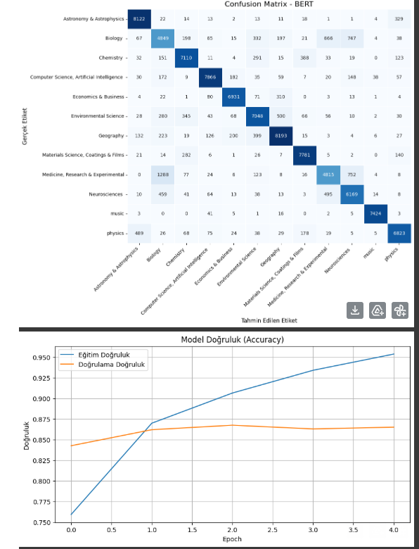

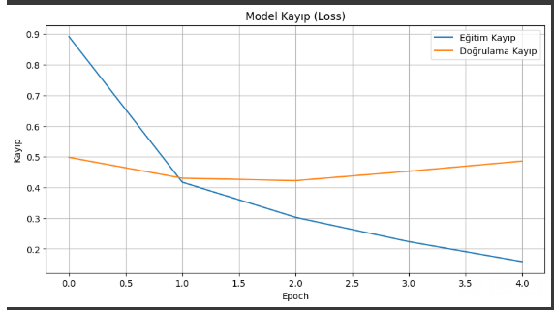

The Version of the SVM, Random Forest, Naïve Bias Codes with a GPU Measurement and Time Counter Added, the Results of Which are Given in the Article :

#yukarıdaki kodun hakem için gpu yükü güncellemesi almış versiyonu
# Değişiklik yapılan kısım dışında orijinal kodun aynısıdır

import pandas as pd
import re
import matplotlib.pyplot as plt
import seaborn as sns
from sklearn.model_selection import train_test_split
from sklearn.feature_extraction.text import TfidfVectorizer
from sklearn.naive_bayes import MultinomialNB
from sklearn.ensemble import RandomForestClassifier
from sklearn.svm import SVC
from sklearn.pipeline import Pipeline
from sklearn.metrics import classification_report, confusion_matrix
import time
import psutil
import GPUtil
import platform
import numpy as np
from sklearn.preprocessing import LabelEncoder

def get_system_metrics():
cpu_percent = psutil.cpu_percent(interval=None)
ram_info = psutil.virtual_memory()
ram_used_gb = round(ram_info.used / (1024**3), 2)
ram_total_gb = round(ram_info.total / (1024**3), 2)

gpu_info = []
try:
gpus = GPUtil.getGPUs()
if gpus:
for gpu in gpus:
gpu_info.append({
"name": gpu.name,
"load": f"{gpu.load*100:.1f}%",
"memory_used_mb": gpu.memoryUsed,
"memory_total_mb": gpu.memoryTotal
})
else:
gpu_info.append({"status": "GPU Yok veya Tanımlı Değil"})
except Exception as e:
gpu_info.append({"status": f"GPU Bilgisi Alınamadı: {e}"})

return {
"cpu_percent": cpu_percent,
"ram_used_gb": ram_used_gb,
"ram_total_gb": ram_total_gb,
"gpu_info": gpu_info
}

def print_metrics(phase, metrics, model_name=""):
print(f"\n--- {model_name} - {phase} Metrikleri ---")
print(f"CPU Kullanımı: {metrics['cpu_percent']} %")
print(f"RAM Kullanımı: {metrics['ram_used_gb']} GB / {metrics['ram_total_gb']} GB")

for gpu in metrics['gpu_info']:
if "status" in gpu:
print(f"GPU: {gpu['status']}")
else:
print(f"GPU ({gpu['name']}) Kullanım: {gpu['load']} | Bellek: {gpu['memory_used_mb']}/{gpu['memory_total_mb']} MB")
print("---------------------------------------")

def download_dataset():
file_path = '/content/drive/MyDrive/Text Classification Tez Çalışması/inputs for final task/bbc_data_Format_151K.xlsx'
try:
data = pd.read_excel(file_path)
return data
except Exception as e:
print(f"Veri seti yüklenirken hata oluştu: {e}")
return None

def clean_text(text):
text = re.sub(r'[^\w\s]', '', text)
text = re.sub(r'\s+', ' ', text)
return text.lower()

def fill_missing_values(data):
data.dropna(inplace=True)
return data

def split_data(data):
X = data['text']
y = data['category']
return train_test_split(X, y, test_size=0.8, random_state=42, stratify=y)

def train_and_evaluate(X_train, X_test, y_train, y_test, label_encoder):
classifiers = {
"Naive Bayes": MultinomialNB(),
"Random Forest": RandomForestClassifier(random_state=42),
"SVM": SVC(kernel='linear', random_state=42)
}

results = {}

for name, clf in classifiers.items():
print(f"\nModel: {name}")

train_start_time = time.time()
train_start_metrics = get_system_metrics()
print_metrics(f"{name} Eğitim Başlangıç", train_start_metrics, name)

pipeline = Pipeline([
('tfidf', TfidfVectorizer(max_df=0.75, ngram_range=(1, 2))),
('clf', clf)
])

pipeline.fit(X_train, y_train)

train_end_time = time.time()
train_end_metrics = get_system_metrics()
print_metrics(f"{name} Eğitim Bitiş", train_end_metrics, name)

predict_start_time = time.time()
predict_start_metrics = get_system_metrics()
print_metrics(f"{name} Tahmin Başlangıç", predict_start_metrics, name)

predictions = pipeline.predict(X_test)

predict_end_time = time.time()
predict_end_metrics = get_system_metrics()
print_metrics(f"{name} Tahmin Bitiş", predict_end_metrics, name)

total_train_time = train_end_time - train_start_time
total_predict_time = predict_end_time - predict_start_time

# Eğitim ve tahmin sürelerini yazdır
print(f" Eğitim Süresi: {total_train_time:.2f} saniye")
print(f" Tahmin Süresi: {total_predict_time:.2f} saniye")

report = classification_report(y_test, predictions, output_dict=True)
print("\nClassification Report:\n")
print(classification_report(y_test, predictions))

results[name] = {
"training_time_seconds": total_train_time,
"prediction_time_seconds": total_predict_time,
"cpu_usage_train_start_percent": train_start_metrics['cpu_percent'],
"cpu_usage_train_end_percent": train_end_metrics['cpu_percent'],
"ram_used_train_start_gb": train_start_metrics['ram_used_gb'],
"ram_used_train_end_gb": train_end_metrics['ram_used_gb'],
"cpu_usage_predict_start_percent": predict_start_metrics['cpu_percent'],
"cpu_usage_predict_end_percent": predict_end_metrics['cpu_percent'],
"ram_used_predict_start_gb": predict_start_metrics['ram_used_gb'],
"ram_used_predict_end_gb": predict_end_metrics['ram_used_gb'],
"ram_total_gb": train_start_metrics['ram_total_gb'],
"gpu_info_train_start": train_start_metrics['gpu_info'],
"gpu_info_train_end": train_end_metrics['gpu_info'],
"gpu_info_predict_start": predict_start_metrics['gpu_info'],
"gpu_info_predict_end": predict_end_metrics['gpu_info'],
"classification_report": report
}

cm = confusion_matrix(y_test, predictions, labels=label_encoder.classes_)
cm_df = pd.DataFrame(cm, index=label_encoder.classes_, columns=label_encoder.classes_)

plt.figure(figsize=(12, 10))
sns.heatmap(cm_df, annot=True, fmt='d', cmap='Blues', cbar=False, linewidths=0.5)

plt.title(f"Confusion Matrix - {name}", fontsize=16)
plt.xlabel("Tahmin Edilen Etiket", fontsize=12)
plt.ylabel("Gerçek Etiket", fontsize=12)

plt.xticks(ticks=np.arange(len(label_encoder.classes_)) + 0.5,
labels=label_encoder.classes_,
rotation=45,
ha='right')

plt.yticks(ticks=np.arange(len(label_encoder.classes_)) + 0.5,
labels=label_encoder.classes_,
rotation=0)

plt.tight_layout()
plt.show()

return results

def main():
start_global_time = time.time()

data = download_dataset()
if data is None:
return

data['text'] = data['text'].apply(clean_text)
data = fill_missing_values(data)

label_encoder = LabelEncoder()
label_encoder.fit(data['category'])

X_train, X_test, y_train, y_test = split_data(data)

evaluation_results = train_and_evaluate(X_train, X_test, y_train, y_test, label_encoder)

end_global_time = time.time()
total_global_time = time.strftime('%H:%M:%S', time.gmtime(end_global_time - start_global_time))

print("\n\n--- Genel Performans Özeti ---")
for name, res in evaluation_results.items():
print(f"\nModel: {name}")
print(f" Eğitim Süresi: {res['training_time_seconds']:.2f} saniye")
print(f" Tahmin Süresi: {res['prediction_time_seconds']:.2f} saniye")
print(f" Eğitim Başlangıç CPU: {res['cpu_usage_train_start_percent']:.2f}% | Bitiş CPU: {res['cpu_usage_train_end_percent']:.2f}%")
print(f" Tahmin Başlangıç CPU: {res['cpu_usage_predict_start_percent']:.2f}% | Bitiş CPU: {res['cpu_usage_predict_end_percent']:.2f}%")
print(f" Eğitim Başlangıç RAM: {res['ram_used_train_start_gb']:.2f} GB | Bitiş RAM: {res['ram_used_train_end_gb']:.2f} GB (Toplam: {res['ram_total_gb']:.2f} GB)")
print(f" Tahmin Başlangıç RAM: {res['ram_used_predict_start_gb']:.2f} GB | Bitiş RAM: {res['ram_used_predict_end_gb']:.2f} GB")

gpu_train_start_info = res['gpu_info_train_start']
gpu_train_end_info = res['gpu_info_train_end']
gpu_predict_start_info = res['gpu_info_predict_start']
gpu_predict_end_info = res['gpu_info_predict_end']

if gpu_train_start_info and "status" not in gpu_train_start_info[0]:
print(f" GPU ({gpu_train_start_info[0]['name']}) Eğitim Başlangıç Kullanım: {gpu_train_start_info[0]['load']} | Bellek: {gpu_train_start_info[0]['memory_used_mb']}/{gpu_train_start_info[0]['memory_total_mb']} MB")
print(f" GPU ({gpu_train_end_info[0]['name']}) Eğitim Bitiş Kullanım: {gpu_train_end_info[0]['load']} | Bellek: {gpu_train_end_info[0]['memory_used_mb']}/{gpu_train_end_info[0]['memory_total_mb']} MB")
print(f" GPU ({gpu_predict_start_info[0]['name']}) Tahmin Başlangıç Kullanım: {gpu_predict_start_info[0]['load']} | Bellek: {gpu_predict_start_info[0]['memory_used_mb']}/{gpu_predict_start_info[0]['memory_total_mb']} MB")
print(f" GPU ({gpu_predict_end_info[0]['name']}) Tahmin Bitiş Kullanım: {gpu_predict_end_info[0]['load']} | Bellek: {gpu_predict_end_info[0]['memory_used_mb']}/{gpu_predict_end_info[0]['memory_total_mb']} MB")
else:
print(f" GPU Bilgisi: {gpu_train_start_info[0]['status']}")

print(" Sınıflandırma Raporu Özeti (Accuracy):", res['classification_report']['accuracy'])

print(f"\nGenel Program Çalışma Süresi: {total_global_time}")
print("\nDonanım Bilgileri:")
print(f"CPU: {platform.processor()}")
print(f"RAM: {round(psutil.virtual_memory().total / (1024**3), 2)} GB")

gpus = GPUtil.getGPUs()
if gpus:
for gpu in gpus:
print(f"GPU: {gpu.name} | Bellek: {gpu.memoryTotal} MB")
else:
print("GPU: Kullanılamıyor veya tanımlı değil.")

if __name__ == "__main__":
main()

Model: Naive Bayes

--- Naive Bayes - Naive Bayes Eğitim Başlangıç Metrikleri ---
CPU Kullanımı: 3.2 %
RAM Kullanımı: 3.71 GB / 83.48 GB
GPU (NVIDIA A100-SXM4-40GB) Kullanım: 0.0% | Bellek: 0.0/40960.0 MB
---------------------------------------

--- Naive Bayes - Naive Bayes Eğitim Bitiş Metrikleri ---
CPU Kullanımı: 10.4 %
RAM Kullanımı: 4.05 GB / 83.48 GB
GPU (NVIDIA A100-SXM4-40GB) Kullanım: 0.0% | Bellek: 0.0/40960.0 MB
---------------------------------------

--- Naive Bayes - Naive Bayes Tahmin Başlangıç Metrikleri ---
CPU Kullanımı: 4.3 %
RAM Kullanımı: 4.06 GB / 83.48 GB
GPU (NVIDIA A100-SXM4-40GB) Kullanım: 0.0% | Bellek: 0.0/40960.0 MB
---------------------------------------

--- Naive Bayes - Naive Bayes Tahmin Bitiş Metrikleri ---
CPU Kullanımı: 10.0 %
RAM Kullanımı: 4.02 GB / 83.48 GB
GPU (NVIDIA A100-SXM4-40GB) Kullanım: 0.0% | Bellek: 0.0/40960.0 MB
---------------------------------------
Eğitim Süresi: 11.12 saniye
Tahmin Süresi: 21.62 saniye

Classification Report:

precision recall f1-score support

Astronomy & Astrophysics 0.90 0.91 0.91 8641
Biology 0.68 0.42 0.52 7199
Chemistry 0.92 0.74 0.82 8248
Computer Science, Artificial Intelligence 0.73 0.95 0.82 8538
Economics & Business 0.95 0.85 0.89 7413
Environmental Science 0.79 0.74 0.77 8396
Geography 0.63 0.92 0.75 9321
Materials Science, Coatings & Films 0.79 0.97 0.87 8383
Medicine, Research & Experimental 0.79 0.61 0.69 7091
Neurosciences 0.74 0.79 0.77 7303
music 0.96 0.91 0.94 7534
physics 0.94 0.72 0.81 7757

accuracy 0.80 95824
macro avg 0.82 0.79 0.80 95824
weighted avg 0.82 0.80 0.80 95824

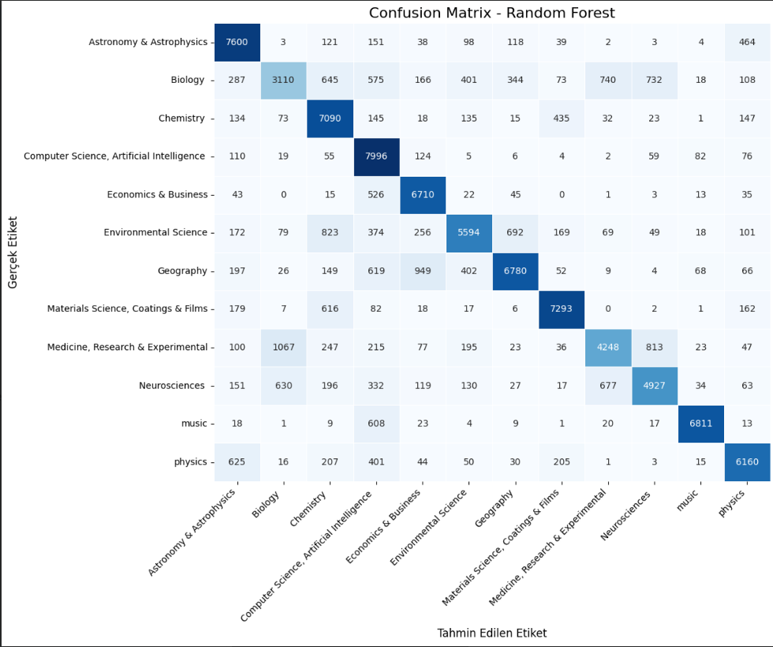
Model: Random Forest

--- Random Forest - Random Forest Eğitim Başlangıç Metrikleri ---
CPU Kullanımı: 13.7 %
RAM Kullanımı: 4.01 GB / 83.48 GB
GPU (NVIDIA A100-SXM4-40GB) Kullanım: 0.0% | Bellek: 0.0/40960.0 MB
---------------------------------------

--- Random Forest - Random Forest Eğitim Bitiş Metrikleri ---
CPU Kullanımı: 10.3 %
RAM Kullanımı: 4.44 GB / 83.48 GB
GPU (NVIDIA A100-SXM4-40GB) Kullanım: 0.0% | Bellek: 0.0/40960.0 MB
---------------------------------------

--- Random Forest - Random Forest Tahmin Başlangıç Metrikleri ---
CPU Kullanımı: 12.0 %
RAM Kullanımı: 4.44 GB / 83.48 GB
GPU (NVIDIA A100-SXM4-40GB) Kullanım: 0.0% | Bellek: 0.0/40960.0 MB
---------------------------------------

--- Random Forest - Random Forest Tahmin Bitiş Metrikleri ---
CPU Kullanımı: 10.1 %
RAM Kullanımı: 4.44 GB / 83.48 GB
GPU (NVIDIA A100-SXM4-40GB) Kullanım: 0.0% | Bellek: 0.0/40960.0 MB
---------------------------------------
Eğitim Süresi: 636.49 saniye
Tahmin Süresi: 42.18 saniye

Classification Report:

precision recall f1-score support

Astronomy & Astrophysics 0.79 0.88 0.83 8641
Biology 0.62 0.43 0.51 7199
Chemistry 0.70 0.86 0.77 8248
Computer Science, Artificial Intelligence 0.67 0.94 0.78 8538
Economics & Business 0.79 0.91 0.84 7413
Environmental Science 0.79 0.67 0.72 8396
Geography 0.84 0.73 0.78 9321
Materials Science, Coatings & Films 0.88 0.87 0.87 8383
Medicine, Research & Experimental 0.73 0.60 0.66 7091
Neurosciences 0.74 0.67 0.71 7303
music 0.96 0.90 0.93 7534
physics 0.83 0.79 0.81 7757

accuracy 0.78 95824
macro avg 0.78 0.77 0.77 95824
weighted avg 0.78 0.78 0.77 95824

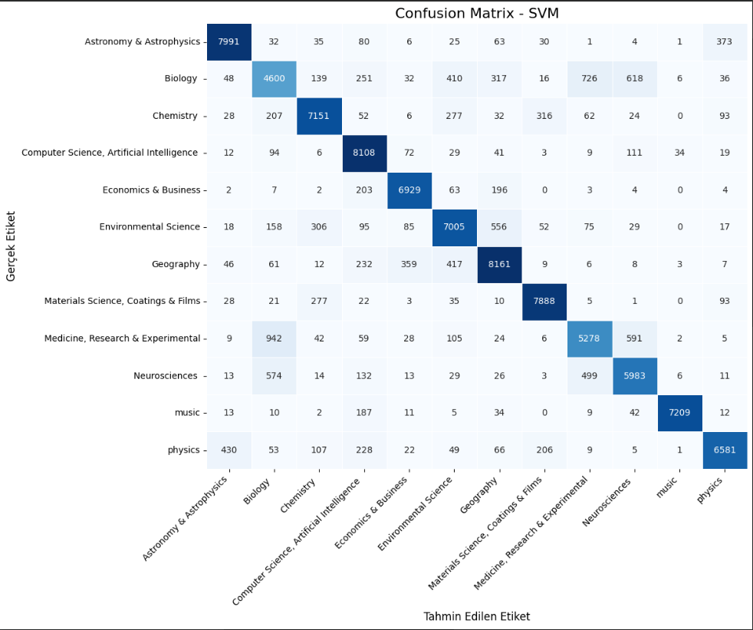
Model: SVM

--- SVM - SVM Eğitim Başlangıç Metrikleri ---
CPU Kullanımı: 15.6 %
RAM Kullanımı: 4.44 GB / 83.48 GB
GPU (NVIDIA A100-SXM4-40GB) Kullanım: 0.0% | Bellek: 0.0/40960.0 MB
---------------------------------------

--- SVM - SVM Eğitim Bitiş Metrikleri ---
CPU Kullanımı: 10.3 %
RAM Kullanımı: 4.47 GB / 83.48 GB
GPU (NVIDIA A100-SXM4-40GB) Kullanım: 0.0% | Bellek: 0.0/40960.0 MB
---------------------------------------

--- SVM - SVM Tahmin Başlangıç Metrikleri ---
CPU Kullanımı: 8.3 %
RAM Kullanımı: 4.48 GB / 83.48 GB
GPU (NVIDIA A100-SXM4-40GB) Kullanım: 0.0% | Bellek: 0.0/40960.0 MB
---------------------------------------

--- SVM - SVM Tahmin Bitiş Metrikleri ---
CPU Kullanımı: 10.3 %
RAM Kullanımı: 4.65 GB / 83.48 GB
GPU (NVIDIA A100-SXM4-40GB) Kullanım: 0.0% | Bellek: 0.0/40960.0 MB
---------------------------------------
Eğitim Süresi: 1342.89 saniye
Tahmin Süresi: 3148.52 saniye

Classification Report:

precision recall f1-score support

Astronomy & Astrophysics 0.93 0.92 0.92 8641
Biology 0.68 0.64 0.66 7199
Chemistry 0.88 0.87 0.88 8248
Computer Science, Artificial Intelligence 0.84 0.95 0.89 8538
Economics & Business 0.92 0.93 0.93 7413
Environmental Science 0.83 0.83 0.83 8396
Geography 0.86 0.88 0.87 9321
Materials Science, Coatings & Films 0.92 0.94 0.93 8383
Medicine, Research & Experimental 0.79 0.74 0.77 7091
Neurosciences 0.81 0.82 0.81 7303
music 0.99 0.96 0.97 7534
physics 0.91 0.85 0.88 7757

accuracy 0.86 95824
macro avg 0.86 0.86 0.86 95824
weighted avg 0.86 0.86 0.86 95824

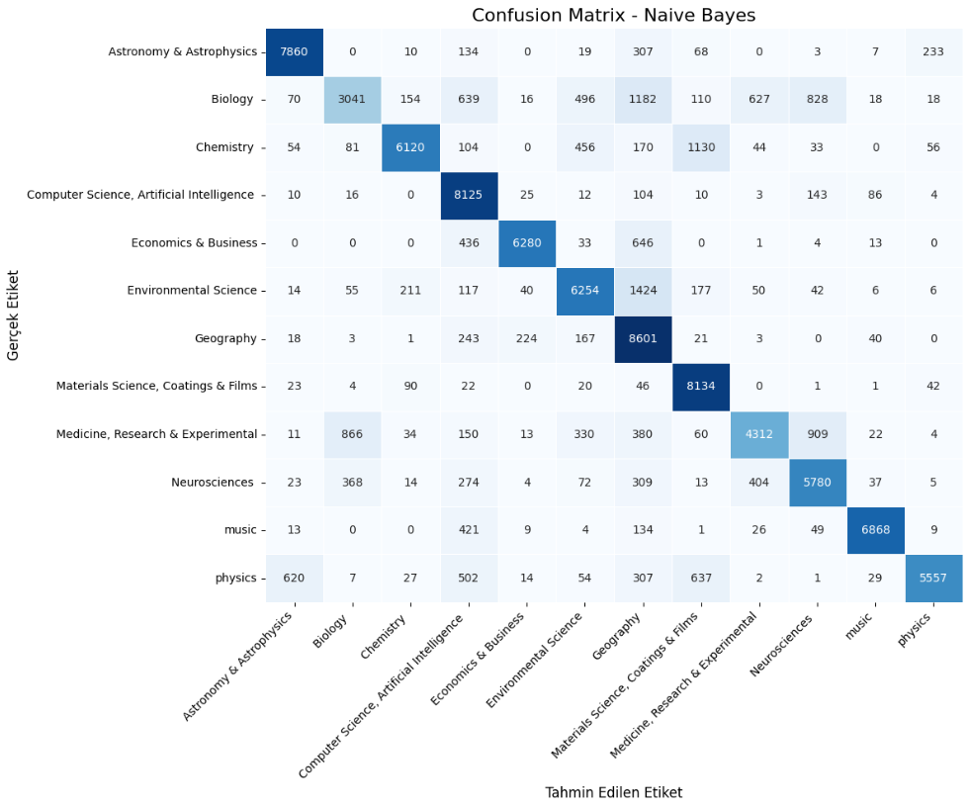
--- Genel Performans Özeti ---

Model: Naive Bayes
Eğitim Süresi: 11.12 saniye
Tahmin Süresi: 21.62 saniye
Eğitim Başlangıç CPU: 3.20% | Bitiş CPU: 10.40%
Tahmin Başlangıç CPU: 4.30% | Bitiş CPU: 10.00%
Eğitim Başlangıç RAM: 3.71 GB | Bitiş RAM: 4.05 GB (Toplam: 83.48 GB)
Tahmin Başlangıç RAM: 4.06 GB | Bitiş RAM: 4.02 GB
GPU (NVIDIA A100-SXM4-40GB) Eğitim Başlangıç Kullanım: 0.0% | Bellek: 0.0/40960.0 MB
GPU (NVIDIA A100-SXM4-40GB) Eğitim Bitiş Kullanım: 0.0% | Bellek: 0.0/40960.0 MB
GPU (NVIDIA A100-SXM4-40GB) Tahmin Başlangıç Kullanım: 0.0% | Bellek: 0.0/40960.0 MB
GPU (NVIDIA A100-SXM4-40GB) Tahmin Bitiş Kullanım: 0.0% | Bellek: 0.0/40960.0 MB
Sınıflandırma Raporu Özeti (Accuracy): 0.8028468859575889

Model: Random Forest
Eğitim Süresi: 636.49 saniye
Tahmin Süresi: 42.18 saniye
Eğitim Başlangıç CPU: 13.70% | Bitiş CPU: 10.30%
Tahmin Başlangıç CPU: 12.00% | Bitiş CPU: 10.10%
Eğitim Başlangıç RAM: 4.01 GB | Bitiş RAM: 4.44 GB (Toplam: 83.48 GB)
Tahmin Başlangıç RAM: 4.44 GB | Bitiş RAM: 4.44 GB
GPU (NVIDIA A100-SXM4-40GB) Eğitim Başlangıç Kullanım: 0.0% | Bellek: 0.0/40960.0 MB
GPU (NVIDIA A100-SXM4-40GB) Eğitim Bitiş Kullanım: 0.0% | Bellek: 0.0/40960.0 MB
GPU (NVIDIA A100-SXM4-40GB) Tahmin Başlangıç Kullanım: 0.0% | Bellek: 0.0/40960.0 MB
GPU (NVIDIA A100-SXM4-40GB) Tahmin Bitiş Kullanım: 0.0% | Bellek: 0.0/40960.0 MB
Sınıflandırma Raporu Özeti (Accuracy): 0.7755781432626482

Model: SVM
Eğitim Süresi: 1342.89 saniye
Tahmin Süresi: 3148.52 saniye
Eğitim Başlangıç CPU: 15.60% | Bitiş CPU: 10.30%
Tahmin Başlangıç CPU: 8.30% | Bitiş CPU: 10.30%
Eğitim Başlangıç RAM: 4.44 GB | Bitiş RAM: 4.47 GB (Toplam: 83.48 GB)
Tahmin Başlangıç RAM: 4.48 GB | Bitiş RAM: 4.65 GB
GPU (NVIDIA A100-SXM4-40GB) Eğitim Başlangıç Kullanım: 0.0% | Bellek: 0.0/40960.0 MB
GPU (NVIDIA A100-SXM4-40GB) Eğitim Bitiş Kullanım: 0.0% | Bellek: 0.0/40960.0 MB
GPU (NVIDIA A100-SXM4-40GB) Tahmin Başlangıç Kullanım: 0.0% | Bellek: 0.0/40960.0 MB
GPU (NVIDIA A100-SXM4-40GB) Tahmin Bitiş Kullanım: 0.0% | Bellek: 0.0/40960.0 MB
Sınıflandırma Raporu Özeti (Accuracy): 0.8649607613958925

Genel Program Çalışma Süresi: 01:27:08

Donanım Bilgileri:
CPU: x86_64
RAM: 83.48 GB
GPU: NVIDIA A100-SXM4-40GB | Bellek: 40960.0 MB

The Version of the Bert Code with a GPU Measurement, K-fold method and Time Counter Added, the Results of Which are Given in the Article :

# kod checkpoint özellikli ve kaldığı fold'dan devam edebilen bir K-Fold BERT sınıflandırma modelidir.

import tensorflow as tf

# !!! ÖNEMLİ: Karma duyarlıklı eğitimi en başta etkinleştirin !!!
# Bu, GPU bellek kullanımını optimize eder ve A100 gibi donanımlarda performansı artırır.
tf.keras.mixed_precision.set_global_policy("mixed_float16")

from transformers import TFBertForSequenceClassification, BertTokenizer
from sklearn.model_selection import StratifiedKFold
from sklearn.preprocessing import LabelEncoder
from sklearn.metrics import classification_report, confusion_matrix
import pandas as pd
import numpy as np
import re
import matplotlib.pyplot as plt
import seaborn as sns
import time
import psutil
import GPUtil
import platform
import os

# Adım 1: Veriyi temizleyen fonksiyon
def clean_text(text):
text = re.sub(r'[^\w\s]', '', text)
text = re.sub(r'\s+', ' ', text)
text = text.lower()
return text

# Adım 3: BERT modelini oluşturma
def create_bert_model(num_labels):
# Modelin doğru dtype'da başlatıldığından emin olmak için from_pt=True kullanmıyoruz.
# Mixed precision policy zaten float16'ya dönüştürecektir.
return TFBertForSequenceClassification.from_pretrained("bert-base-uncased", num_labels=num_labels)

# Learning Rate Scheduler
def lr_scheduler():
# val_loss'taki ani artışları tolere etmek için patience değerini artırdık.
# min_lr'yi daha düşük bir değere çekerek daha ince ayarlamalara izin verdik.
return tf.keras.callbacks.ReduceLROnPlateau(monitor='val_loss', factor=0.5, patience=3, min_lr=1e-7, verbose=1)

# Adım 4: BERT modelini eğitme
def train_bert_model(model, train_data, val_data, epochs, learning_rate):
# Mixed precision etkin olduğunda, optimize edicinin de hassasiyet uyumlu olması gerekir.
# Keras'ın yeni sürümleri bunu otomatik olarak halleder.
optimizer = tf.keras.optimizers.Adam(learning_rate=learning_rate)

# Loss fonksiyonunun from_logits=True olması, modelin son katmanının aktivasyon fonksiyonu olmaması durumunda doğrudur.
loss_fn = tf.keras.losses.SparseCategoricalCrossentropy(from_logits=True)

model.compile(optimizer=optimizer, loss=loss_fn, metrics=["accuracy"])

scheduler = lr_scheduler()
early_stopping = tf.keras.callbacks.EarlyStopping(monitor='val_loss', patience=4, restore_best_weights=True, verbose=1)

model.fit(train_data, validation_data=val_data, epochs=epochs, callbacks=[scheduler, early_stopping], verbose=1)
return model

# Adım 5: Modeli değerlendirme
def evaluate_model(model, val_data, val_labels_encoded, label_encoder):
# Tahmin yaparken model çıktılarının hala float32 olduğundan emin olmak için dtype_policy'e bakılır.
# Mixed precision durumunda model çıktıları genellikle float32 olarak ayarlanır.
predictions = model.predict(val_data)["logits"]
predicted_labels_encoded = np.argmax(predictions, axis=1)

decoded_labels = label_encoder.inverse_transform(val_labels_encoded)
decoded_predictions = label_encoder.inverse_transform(predicted_labels_encoded)

report = classification_report(decoded_labels, decoded_predictions, target_names=label_encoder.classes_, zero_division=0)
print("Sınıflandırma Raporu (BERT):")
print(report)

print("\nSınıf Başına Düşen Eleman Sayısı (Test Seti):")
unique_labels, counts = np.unique(decoded_labels, return_counts=True)
for label, count in zip(unique_labels, counts):
print(f"{label:<40} {count}")

cm = confusion_matrix(decoded_labels, decoded_predictions, labels=label_encoder.classes_)
cm_df = pd.DataFrame(cm, index=label_encoder.classes_, columns=label_encoder.classes_)

plt.figure(figsize=(12, 10))
sns.heatmap(cm_df, annot=True, fmt='d', cmap='Blues', cbar=False, linewidths=0.5)
plt.title("Confusion Matrix - BERT", fontsize=16)
plt.xlabel("Tahmin Edilen Etiket", fontsize=12)
plt.ylabel("Gerçek Etiket", fontsize=12)
plt.xticks(ticks=np.arange(len(label_encoder.classes_)) + 0.5, labels=label_encoder.classes_, rotation=45, ha='right')
plt.yticks(ticks=np.arange(len(label_encoder.classes_)) + 0.5, labels=label_encoder.classes_, rotation=0)
plt.tight_layout()
plt.show()

# Ana program
if __name__ == "__main__":
start_time = time.time()

file_path = '/content/drive/MyDrive/Text Classification Tez Çalışması/inputs for final task/bbc_data_Format_151K.xlsx'
data = pd.read_excel(file_path)
data['text'] = data['text'].apply(clean_text)

label_encoder = LabelEncoder()
data['category_encoded'] = label_encoder.fit_transform(data['category'])

tokenizer = BertTokenizer.from_pretrained("bert-base-uncased")
max_length = 384

save_dir = '/content/drive/MyDrive/bert_kfold_checkpoints'
os.makedirs(save_dir, exist_ok=True)

completed_folds_file = os.path.join(save_dir, 'completed_folds.txt')

completed_folds = set()
if os.path.exists(completed_folds_file):
with open(completed_folds_file, 'r') as f:
for line in f:
try:
completed_folds.add(int(line.strip()))
except ValueError:
continue
print(f"Daha önce tamamlanmış foldlar: {sorted(list(completed_folds))}")

kf = StratifiedKFold(n_splits=5, shuffle=True, random_state=42)

for fold, (train_idx, val_idx) in enumerate(kf.split(data['text'], data['category_encoded']), 1):
if fold in completed_folds:
print(f"\n--- Fold {fold} zaten tamamlanmış, atlanıyor. ---")
continue

print(f"\n=== Fold {fold} ===")

X_train, X_val = data['text'].iloc[train_idx], data['text'].iloc[val_idx]
y_train, y_val = data['category_encoded'].iloc[train_idx], data['category_encoded'].iloc[val_idx]

train_encodings = tokenizer(list(X_train), truncation=True, padding='max_length', max_length=max_length, return_tensors="tf")
val_encodings = tokenizer(list(X_val), truncation=True, padding='max_length', max_length=max_length, return_tensors="tf")

BUFFER_SIZE = tf.data.AUTOTUNE
# Başarıyı geri kazanmak ve GPU RAM'ı daha çok kullanmak için BATCH_SIZE'ı 64'e geri çıkarıyoruz.
# Mixed Precision etkin olduğu için bellek hatası almamamız beklenir.
BATCH_SIZE = 64

train_dataset = tf.data.Dataset.from_tensor_slices(({
"input_ids": train_encodings["input_ids"],
"attention_mask": train_encodings["attention_mask"]
gpus = GPUtil.getGPUs()
if gpus:
for gpu in gpus:
print(f"GPU: {gpu.name} | Kullanım: {gpu.load*100:.1f}% | Bellek: {gpu.memoryUsed}/{gpu.memoryTotal} MB")
else:
print("GPU: Kullanılamıyor veya tanımlı değil.")

tokenizer_config.json: 100%
48.0/48.0 [00:00<00:00, 6.45kB/s]
vocab.txt: 100%
232k/232k [00:00<00:00, 2.36MB/s]
tokenizer.json: 100%
466k/466k [00:00<00:00, 6.46MB/s]
config.json: 100%
570/570 [00:00<00:00, 72.7kB/s]
Daha önce tamamlanmış foldlar: [1, 2, 3, 4]

--- Fold 1 zaten tamamlanmış, atlanıyor. ---

--- Fold 2 zaten tamamlanmış, atlanıyor. ---

--- Fold 3 zaten tamamlanmış, atlanıyor. ---

--- Fold 4 zaten tamamlanmış, atlanıyor. ---

=== Fold 5 ===
model.safetensors: 100%
440M/440M [00:01<00:00, 557MB/s]
All PyTorch model weights were used when initializing TFBertForSequenceClassification.

Some weights or buffers of the TF 2.0 model TFBertForSequenceClassification were not initialized from the PyTorch model and are newly initialized: ['classifier.weight', 'classifier.bias']
You should probably TRAIN this model on a down-stream task to be able to use it for predictions and inference.
Epoch 1/10
1498/1498 [==============================] - 780s 490ms/step - loss: 0.5038 - accuracy: 0.8459 - val_loss: 0.3429 - val_accuracy: 0.8825 - lr: 2.0000e-05
Epoch 2/10
1498/1498 [==============================] - 696s 465ms/step - loss: 0.2703 - accuracy: 0.9095 - val_loss: 0.3008 - val_accuracy: 0.9010 - lr: 2.0000e-05
Epoch 3/10
1498/1498 [==============================] - 691s 461ms/step - loss: 0.1899 - accuracy: 0.9372 - val_loss: 0.3105 - val_accuracy: 0.9019 - lr: 2.0000e-05
Epoch 4/10
1498/1498 [==============================] - 690s 461ms/step - loss: 0.1310 - accuracy: 0.9573 - val_loss: 0.3454 - val_accuracy: 0.8990 - lr: 2.0000e-05
Epoch 5/10
1498/1498 [==============================] - ETA: 0s - loss: 0.0901 - accuracy: 0.9705
Epoch 5: ReduceLROnPlateau reducing learning rate to 9.999999747378752e-06.
1498/1498 [==============================] - 689s 460ms/step - loss: 0.0901 - accuracy: 0.9705 - val_loss: 0.3552 - val_accuracy: 0.9044 - lr: 2.0000e-05
Epoch 6/10
1498/1498 [==============================] - 689s 460ms/step - loss: 0.0459 - accuracy: 0.9863 - val_loss: 0.3935 - val_accuracy: 0.9064 - lr: 1.0000e-05
Epoch 6: early stopping
Restoring model weights from the end of the best epoch: 2.
749/749 [==============================] - 62s 78ms/step
Sınıflandırma Raporu (BERT):
precision recall f1-score support

Astronomy & Astrophysics 0.95 0.94 0.95 2160
Biology 0.73 0.74 0.74 1800
Chemistry 0.94 0.89 0.92 2062
Computer Science, Artificial Intelligence 0.95 0.91 0.93 2134
Economics & Business 0.95 0.95 0.95 1854
Environmental Science 0.84 0.92 0.88 2099
Geography 0.90 0.93 0.92 2330
Materials Science, Coatings & Films 0.96 0.96 0.96 2096
Medicine, Research & Experimental 0.81 0.80 0.81 1772
Neurosciences 0.88 0.80 0.83 1826
music 0.98 0.99 0.99 1884
physics 0.91 0.91 0.91 1939

accuracy 0.90 23956
macro avg 0.90 0.90 0.90 23956
weighted avg 0.90 0.90 0.90 23956

Sınıf Başına Düşen Eleman Sayısı (Test Seti):
Astronomy & Astrophysics 2160
Biology 1800
Chemistry 2062
Computer Science, Artificial Intelligence 2134
Economics & Business 1854
Environmental Science 2099
Geography 2330
Materials Science, Coatings & Films 2096
Medicine, Research & Experimental 1772
Neurosciences 1826
music 1884
physics 1939

Fold 5 modeli ağırlıkları '/content/drive/MyDrive/bert_kfold_checkpoints/bert_fold_5_weights.h5' konumuna kaydedildi.

Toplam Eğitim Süreci: 01:17:52

Donanım Bilgileri:
CPU: x86_64
CPU Kullanımı: 6.2 %
RAM: 83.48 GB (Kullanılan: 15.56 GB, Oran: 19.7%)
GPU: NVIDIA A100-SXM4-40GB | Kullanım: 0.0% | Bellek: 33299.0/40960.0 MB
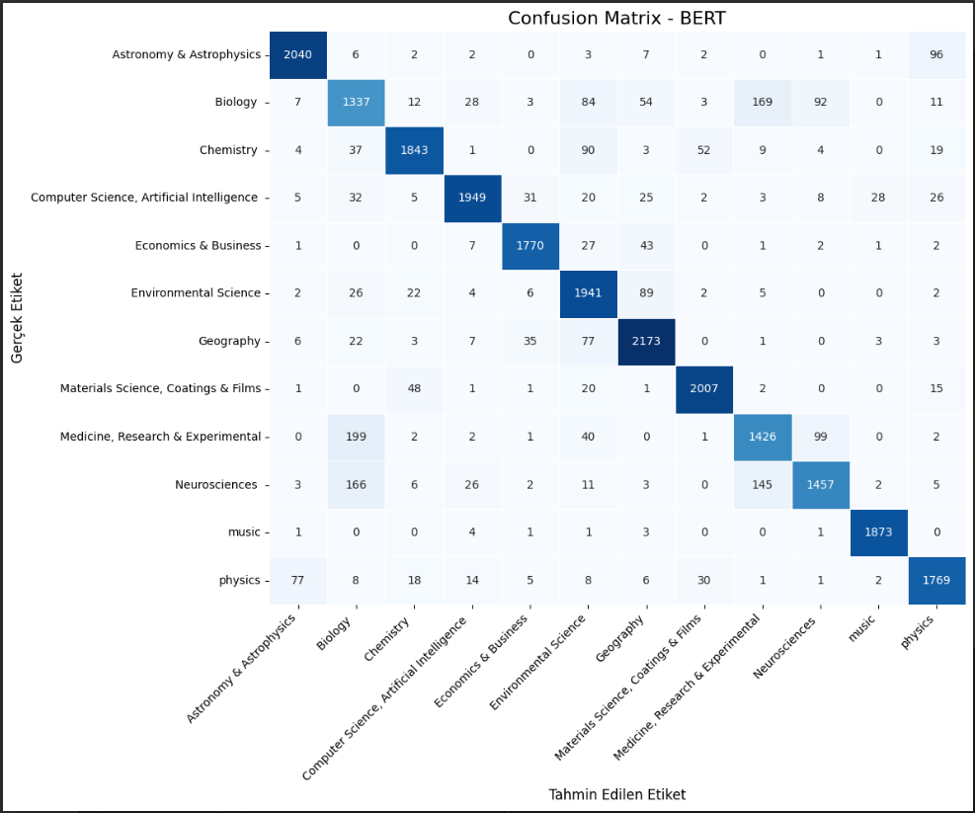

Comparison of Scibert Version of Classification Function Created with the Same Database for Domain Specific Embeddings
#yukarıdaki scibert üzerine geliştirme denemesi.

import time
import psutil
import GPUtil
import platform
import pandas as pd
import numpy as np
import matplotlib.pyplot as plt
import seaborn as sns
from sklearn.model_selection import train_test_split
from sklearn.preprocessing import LabelEncoder
from sklearn.metrics import classification_report, confusion_matrix, f1_score
from transformers import AutoTokenizer, TFAutoModelForSequenceClassification
import tensorflow as tf
import re

def get_system_metrics():
cpu = psutil.cpu_percent()
ram = psutil.virtual_memory()
gpu_info = []
try:
for g in GPUtil.getGPUs():
gpu_info.append((g.name, f"{g.load*100:.1f}%", f"{g.memoryUsed}/{g.memoryTotal}MB"))
except:
gpu_info = [("GPU","Unavailable","")]
return cpu, ram.used/(1024**3), ram.total/(1024**3), gpu_info

def print_metrics(step, t0, t1):
cpu, ram_u, ram_t, gpu = get_system_metrics()
print(f"\n--- {step} Metrikleri ---")
print(f"CPU: {cpu:.1f}% | RAM: {ram_u:.2f}GB/{ram_t:.2f}GB")
for name, load, mem in gpu:
print(f"GPU ({name}): {load} | {mem}")
print(f"Gerçek Süre: {t1-t0:.2f}s")
print("-"*40)

if __name__ == "__main__":
# Sistem bilgisi
info = {
"platform": platform.platform(),
"processor": platform.processor(),
"cores": psutil.cpu_count(),
"ram_GB": round(psutil.virtual_memory().total/(1024**3),2),
"gpu_names": [g.name for g in GPUtil.getGPUs()]
}
print("[INFO] Sistem:", info)

# 1) Veri yükle & temizle
t0 = time.time()
df = pd.read_excel(
"/content/drive/MyDrive/Text Classification Tez Çalışması/inputs for final task/bbc_data_Format_151K.xlsx"
)[['text','category']].dropna()
df['text'] = df['text'].str.replace(r'[^\w\s]','',regex=True).str.lower()
t1 = time.time()
print_metrics("scibert Veri Temizleme", t0, t1)

# 2) Etiket kodlama
t0 = time.time()
le = LabelEncoder()
df['label'] = le.fit_transform(df['category'])
t1 = time.time()
print_metrics("scibert Etiket Kodlama", t0, t1)

# 3) Bölme
t0 = time.time()
X_train, X_test, y_train, y_test = train_test_split(
df['text'].tolist(), df['label'].tolist(),
test_size=0.2, random_state=42, stratify=df['label']
)
t1 = time.time()
print_metrics("scibert Veri Bölme", t0, t1)

# 4) Tokenizer & Model hazırla
MODEL = "allenai/scibert_scivocab_uncased"
t0 = time.time()
tokenizer = AutoTokenizer.from_pretrained(MODEL)
model = TFAutoModelForSequenceClassification.from_pretrained(
MODEL, num_labels=len(le.classes_), from_pt=True
)
t1 = time.time()
print_metrics("scibert Model & Tokenizer Hazırla", t0, t1)

# 5) Tokenleştirme (max_length=128)
t0 = time.time()
enc_train = tokenizer(
X_train, truncation=True, padding="max_length", max_length=128, return_tensors="tf"
)
enc_test = tokenizer(
X_test, truncation=True, padding="max_length", max_length=128, return_tensors="tf"
)
t1 = time.time()
print_metrics("scibert Tokenleştirme", t0, t1)

# 6) Dataset (batch_size=16)
t0 = time.time()
train_ds = tf.data.Dataset.from_tensor_slices((dict(enc_train), y_train))\
.shuffle(10000).batch(16).prefetch(tf.data.AUTOTUNE)
test_ds = tf.data.Dataset.from_tensor_slices((dict(enc_test), y_test))\
.batch(16).prefetch(tf.data.AUTOTUNE)
t1 = time.time()
print_metrics("scibert Dataset Oluşturma", t0, t1)

# 7) Compile
optimizer = tf.keras.optimizers.Adam(learning_rate=2e-5)
loss_fn = tf.keras.losses.SparseCategoricalCrossentropy(from_logits=True)
model.compile(optimizer=optimizer, loss=loss_fn, metrics=["accuracy"])

# 8) Train (epochs=4)
print("\n--- scibert Model Eğitimi Başlıyor ---")
history = model.fit(train_ds, validation_data=test_ds, epochs=4, verbose=1)

# 9) Değerlendirme
print("\n--- scibert Model Değerlendirme ---")
preds = model.predict(test_ds).logits
y_pred = np.argmax(preds, axis=1)

report = classification_report(y_test, y_pred, target_names=le.classes_)
print(report)
cm = confusion_matrix(y_test, y_pred)
sns.heatmap(cm, annot=True, fmt="d",
xticklabels=le.classes_, yticklabels=le.classes_,
cmap="Blues", linewidths=0.5)
plt.title("Confusion Matrix - scibert")
plt.xticks(rotation=45,ha="right")
plt.show()

acc = (y_pred == y_test).mean()
f1w = f1_score(y_test, y_pred, average="weighted")
print(f"Toplam Doğruluk (Accuracy): {acc:.4f}")
print(f"Ağırlıklı F1 Skoru: {f1w:.4f}")

# 10) En çok karışan iki sınıf arasındaki hatalı örnekler
cm_counts = confusion_matrix(y_test, y_pred)
np.fill_diagonal(cm_counts, 0)
i, j = np.unravel_index(cm_counts.argmax(), cm_counts.shape)
mis_idxs = [idx for idx,(t,p) in enumerate(zip(y_test,y_pred)) if t==i and p==j]
orig_idxs = [df.index[idx] for idx in mis_idxs]
print(f"En çok karışan sınıflar: {le.classes_[i]} -> {le.classes_[j]}")
print(f"Yanlış sınıflandırılan örnekler (satır numaraları): {orig_idxs}")

print("\n[INFO] Tamamlandı.")

[INFO] Sistem: {'platform': 'Linux-6.1.123+-x86_64-with-glibc2.35', 'processor': 'x86_64', 'cores': 12, 'ram_GB': 83.48, 'gpu_names': ['NVIDIA A100-SXM4-40GB']}

--- scibert Veri Temizleme Metrikleri ---
CPU: 14.5% | RAM: 3.87GB/83.48GB
GPU (NVIDIA A100-SXM4-40GB): 0.0% | 0.0/40960.0MB
Gerçek Süre: 14.35s
----------------------------------------

--- scibert Etiket Kodlama Metrikleri ---
CPU: 43.5% | RAM: 3.89GB/83.48GB
GPU (NVIDIA A100-SXM4-40GB): 0.0% | 0.0/40960.0MB
Gerçek Süre: 0.02s
----------------------------------------

--- scibert Veri Bölme Metrikleri ---
CPU: 30.5% | RAM: 3.91GB/83.48GB
GPU (NVIDIA A100-SXM4-40GB): 0.0% | 0.0/40960.0MB
Gerçek Süre: 0.09s
----------------------------------------
/usr/local/lib/python3.11/dist-packages/huggingface_hub/utils/_auth.py:94: UserWarning:
The secret `HF_TOKEN` does not exist in your Colab secrets.
To authenticate with the Hugging Face Hub, create a token in your settings tab (https://huggingface.co/settings/tokens), set it as secret in your Google Colab and restart your session.
You will be able to reuse this secret in all of your notebooks.
Please note that authentication is recommended but still optional to access public models or datasets.
warnings.warn(
config.json: 100%
385/385 [00:00<00:00, 30.6kB/s]
vocab.txt:
228k/? [00:00<00:00, 4.06MB/s]
pytorch_model.bin: 100%
442M/442M [00:01<00:00, 342MB/s]
TensorFlow and JAX classes are deprecated and will be removed in Transformers v5. We recommend migrating to PyTorch classes or pinning your version of Transformers.
All PyTorch model weights were used when initializing TFBertForSequenceClassification.

Some weights or buffers of the TF 2.0 model TFBertForSequenceClassification were not initialized from the PyTorch model and are newly initialized: ['classifier.weight', 'classifier.bias']
You should probably TRAIN this model on a down-stream task to be able to use it for predictions and inference.
TensorFlow and JAX classes are deprecated and will be removed in Transformers v5. We recommend migrating to PyTorch classes or pinning your version of Transformers.

--- scibert Model & Tokenizer Hazırla Metrikleri ---
CPU: 26.0% | RAM: 5.97GB/83.48GB
GPU (NVIDIA A100-SXM4-40GB): 10.0% | 1461.0/40960.0MB
Gerçek Süre: 8.56s
----------------------------------------

--- scibert Tokenleştirme Metrikleri ---
CPU: 66.6% | RAM: 10.83GB/83.48GB
GPU (NVIDIA A100-SXM4-40GB): 0.0% | 1461.0/40960.0MB
Gerçek Süre: 19.48s
----------------------------------------

--- scibert Dataset Oluşturma Metrikleri ---
CPU: 10.5% | RAM: 10.83GB/83.48GB
GPU (NVIDIA A100-SXM4-40GB): 0.0% | 1461.0/40960.0MB
Gerçek Süre: 0.16s
----------------------------------------

--- scibert Model Eğitimi Başlıyor ---
Epoch 1/4
5989/5989 [==============================] - 462s 70ms/step - loss: 0.4219 - accuracy: 0.8625 - val_loss: 0.3406 - val_accuracy: 0.8858
Epoch 2/4
5989/5989 [==============================] - 395s 66ms/step - loss: 0.2628 - accuracy: 0.9126 - val_loss: 0.3260 - val_accuracy: 0.8926
Epoch 3/4
5989/5989 [==============================] - 394s 66ms/step - loss: 0.1670 - accuracy: 0.9450 - val_loss: 0.3654 - val_accuracy: 0.8905
Epoch 4/4
5989/5989 [==============================] - 393s 66ms/step - loss: 0.1045 - accuracy: 0.9664 - val_loss: 0.4364 - val_accuracy: 0.8816

--- scibert Model Değerlendirme ---
1498/1498 [==============================] - 41s 25ms/step
precision recall f1-score support

Astronomy & Astrophysics 0.94 0.93 0.94 2160
Biology 0.72 0.72 0.72 1800
Chemistry 0.92 0.87 0.90 2062
Computer Science, Artificial Intelligence 0.93 0.95 0.94 2135
Economics & Business 0.96 0.93 0.94 1853
Environmental Science 0.79 0.90 0.84 2099
Geography 0.88 0.90 0.89 2330
Materials Science, Coatings & Films 0.94 0.93 0.93 2096
Medicine, Research & Experimental 0.75 0.82 0.78 1773
Neurosciences 0.87 0.72 0.79 1826
music 0.98 0.99 0.98 1883
physics 0.91 0.88 0.89 1939

accuracy 0.88 23956
macro avg 0.88 0.88 0.88 23956
weighted avg 0.88 0.88 0.88 23956

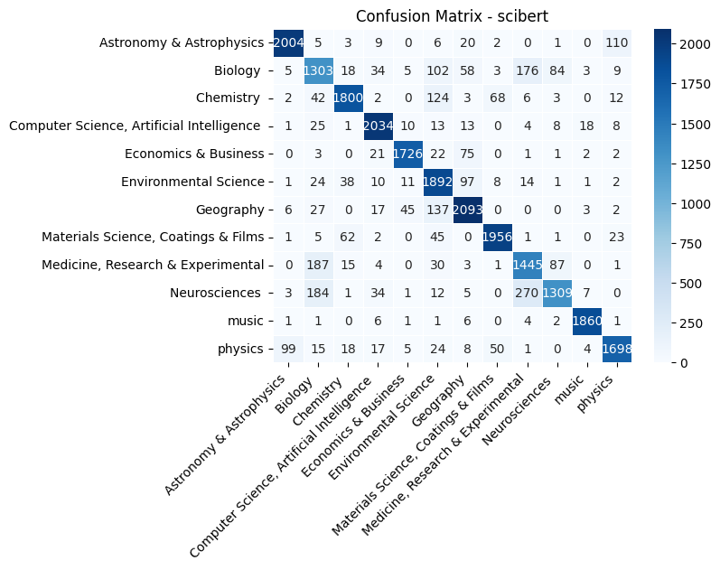
Toplam Doğruluk (Accuracy): 0.8816
Ağırlıklı F1 Skoru: 0.8817
En çok karışan sınıflar: Neurosciences -> Medicine, Research & Experimental
Yanlış sınıflandırılan örnekler (satır numaraları): [203, 226, 368, 664, 739, 888, 893, 996, 1001, 1066, 1125, 1167, 1309, 1336, 1356, 1363, 1414, 1434, 1559, 1574, 1692, 1767, 1769, 1780, 1959, 1965, 2131, 2176, 2448, 2528, 2671, 2925, 2988, 3167, 3203, 3263, 3413, 3456, 3484, 3691, 3726, 3750, 3801, 3806, 3955, 3959, 4113, 4220, 4250, 4270, 4356, 4422, 4705, 4736, 4835, 4844, 4863, 4909, 5244, 5333, 5443, 5454, 5506, 5542, 5596, 5618, 5683, 5959, 5982, 6187, 6223, 6242, 6501, 6580, 6728, 6808, 6897, 6923, 6986, 7022, 7103, 7114, 7154, 7264, 7276, 7379, 7543, 7652, 7669, 7818, 7833, 7834, 7879, 7952, 7960, 8033, 8057, 8161, 8268, 8331, 8515, 8555, 8590, 8783, 8875, 8885, 8919, 8951, 9021, 9026, 9144, 9219, 9239, 9432, 9540, 9604, 9712, 9758, 9804, 9852, 9988, 10067, 10216, 10302, 10619, 10633, 10745, 10847, 10916, 10919, 11073, 11124, 11131, 11181, 11215, 11251, 11390, 11556, 11559, 11589, 11698, 11775, 11778, 11859, 12083, 12088, 12208, 12283, 12288, 12343, 12366, 12508, 12529, 12716, 12739, 12810, 13075, 13375, 13378, 13385, 13525, 13643, 13695, 13716, 13767, 13819, 13978, 14065, 14079, 14396, 14464, 14470, 14516, 14569, 14623, 14652, 14698, 14798, 15018, 15272, 15312, 15365, 15386, 15391, 15412, 15449, 15511, 15548, 15591, 15894, 15937, 15971, 16040, 16257, 16300, 16558, 16633, 16700, 16745, 16800, 16973, 17116, 17264, 17288, 17413, 17440, 17508, 17577, 17677, 17704, 17786, 17812, 17813, 18443, 18717, 18763, 18867, 18894, 18939, 18950, 19090, 19419, 19435, 19452, 19468, 19511, 19512, 19577, 19593, 19664, 19845, 20066, 20320, 20549, 20599, 20663, 20767, 20778, 20866, 20938, 21086, 21090, 21145, 21313, 21318, 21439, 21599, 21727, 21741, 21961, 21964, 22003, 22012, 22075, 22135, 22180, 22185, 22412, 22415, 22450, 22500, 22755, 22861, 22865, 23056, 23277, 23335, 23452, 23545, 23925]

[INFO] Tamamlandı.

Distilbert Version of Classification Function

#paper da raporlanan bert modelinin distilbert versiyonu

import tensorflow as tf

# !!! ÖNEMLİ: Karma duyarlıklı eğitimi en başta etkinleştirin !!!
# Bu, GPU bellek kullanımını optimize eder ve A100 gibi donanımlarda performansı artırır.
tf.keras.mixed_precision.set_global_policy("mixed_float16")

# BERT yerine DistilBERT için gerekli importlar
from transformers import TFDistilBertForSequenceClassification, DistilBertTokenizer
from sklearn.model_selection import train_test_split
from sklearn.preprocessing import LabelEncoder
from sklearn.metrics import classification_report, confusion_matrix, f1_score, accuracy_score
import pandas as pd
import numpy as np
import re
import matplotlib.pyplot as plt
import seaborn as sns
import time
import psutil
import platform
import GPUtil
import os

# --- PERFORMANS İZLEME FONKSİYONLARI ---
def get_system_metrics():
"""Anlık CPU, RAM ve GPU kullanım metriklerini döndürür."""
cpu_percent = psutil.cpu_percent(interval=None)
ram_info = psutil.virtual_memory()
ram_used_gb = round(ram_info.used / (1024**3), 2)
ram_total_gb = round(ram_info.total / (1024**3), 2)

gpu_info = []
try:
gpus = GPUtil.getGPUs()
if gpus:
for gpu in gpus:
gpu_info.append({
"name": gpu.name,
"load": f"{gpu.load*100:.1f}%",
"memory_used_mb": gpu.memoryUsed,
"memory_total_mb": gpu.memoryTotal
})
else:
gpu_info.append({"status": "GPU Yok veya Tanımlı Değil"})
except Exception as e:
gpu_info.append({"status": f"GPU Bilgisi Alınamadı: {e}"})

return {
"cpu_percent": cpu_percent,
"ram_used_gb": ram_used_gb,
"ram_total_gb": ram_total_gb,
"gpu_info": gpu_info,
"processor": platform.processor()
}

def print_metrics_and_time(phase, start_time, end_time, metrics, action_type="işlem"):
"""Belirtilen faz için sistem metriklerini ve süreyi yazdırır."""
elapsed_time = end_time - start_time
print(f"\n--- {phase} ({action_type}) Metrikleri ---")
print(f"İşlemci: {metrics['processor']}")
print(f"CPU Kullanımı: {metrics['cpu_percent']} %")
print(f"RAM Kullanımı: {metrics['ram_used_gb']} GB / {metrics['ram_total_gb']} GB")

for gpu in metrics['gpu_info']:
if "status" in gpu:
print(f"GPU: {gpu['status']}")
else:
print(f"GPU ({gpu['name']}) Kullanım: {gpu['load']} | Bellek: {gpu['memory_used_mb']}/{gpu['memory_total_mb']} MB")
print(f"Gerçek Süre: {elapsed_time:.2f} saniye")
print("---------------------------------------")

# GPU Bellek Büyümesi Ayarı
def set_gpu_memory_growth():
gpus = tf.config.list_physical_devices('GPU')
if gpus:
try:
for gpu in gpus:
tf.config.experimental.set_memory_growth(gpu, True)
print("[INFO] GPU bellek büyümesi (memory growth) başarıyla ayarlandı.")
except RuntimeError as e:
print(f"[HATA] GPU bellek büyümesi ayarlanırken hata oluştu: {e}")
else:
print("[INFO] GPU bulunamadı, bellek büyümesi ayarı atlandı.")

# --- PERFORMANS İZLEME FONKSİYONLARI SONU ---

# Adım 1: Veriyi temizleyen fonksiyon
def clean_text(text):
text = re.sub(r'[^\w\s]', '', text)
text = re.sub(r'\s+', ' ', text)
text = text.lower()
return text

# Adım 2: Veriyi bölme
def split_data(data):
X = data['text']
y = data['category']
# Orijinal indeksleri korumak için, X'in indekslerini de döndürüyoruz
return train_test_split(X, y, test_size=0.2, random_state=42, stratify=y)

# Adım 3: DistilBERT modelini oluşturma
def create_distilbert_model(num_labels):
return TFDistilBertForSequenceClassification.from_pretrained("distilbert-base-uncased", num_labels=num_labels)

# Learning Rate Scheduler
def lr_scheduler():
return tf.keras.callbacks.ReduceLROnPlateau(
monitor='val_loss',
factor=0.5,
patience=2,
min_lr=1e-7,
verbose=1
)

# Adım 4: DistilBERT modelini eğitme
def train_distilbert_model(model, train_data, val_data, epochs, learning_rate):
optimizer = tf.keras.optimizers.Adam(learning_rate=learning_rate)
loss_fn = tf.keras.losses.SparseCategoricalCrossentropy(from_logits=True)
metrics = ["accuracy"]

print("\n--- Model Derleme İşlemi Başlıyor ---")
compile_start_time = time.time()
compile_start_metrics = get_system_metrics()

model.compile(optimizer=optimizer, loss=loss_fn, metrics=metrics)

compile_end_time = time.time()
compile_end_metrics = get_system_metrics()
print_metrics_and_time("Derleme", compile_start_time, compile_end_time, compile_start_metrics, "kod derleme")

scheduler = lr_scheduler()

early_stopping = tf.keras.callbacks.EarlyStopping(
monitor='val_loss',
patience=4,
restore_best_weights=True,
verbose=1
)

print("\n--- Model Eğitim İşlemi Başlıyor ---")
train_start_time = time.time()
train_start_metrics = get_system_metrics()

history = model.fit(
train_data,
validation_data=val_data,
epochs=epochs,
callbacks=[scheduler, early_stopping],
verbose=1
)

train_end_time = time.time()
train_end_metrics = get_system_metrics()
print_metrics_and_time("Eğitim", train_start_time, train_end_time, train_start_metrics, "model eğitim")

return model, history

# Adım 5: Modeli değerlendirme ve sonuçları raporlama + Confusion Matrix
def evaluate_model(model, val_data_input_dict, val_labels_encoded, label_encoder):
predictions = model.predict(val_data_input_dict)["logits"]
predicted_labels_encoded = np.argmax(predictions, axis=1)

decoded_labels = label_encoder.inverse_transform(val_labels_encoded)
decoded_predictions = label_encoder.inverse_transform(predicted_labels_encoded)

report = classification_report(decoded_labels, decoded_predictions, target_names=label_encoder.classes_, zero_division=0)
print("\nSınıflandırma Raporu (DistilBERT):")
print(report)

accuracy = accuracy_score(decoded_labels, decoded_predictions)
f1_weighted = f1_score(decoded_labels, decoded_predictions, average='weighted', zero_division=0)
print(f"\nToplam Doğruluk (Accuracy): {accuracy:.4f}")
print(f"Ağırlıklı F1 Skoru: {f1_weighted:.4f}")

print("\nSınıf Başına Düşen Eleman Sayısı (Test Seti):")
unique_labels, counts = np.unique(decoded_labels, return_counts=True)
for label, count in zip(unique_labels, counts):
print(f"{label:<40} {count}")

cm = confusion_matrix(decoded_labels, decoded_predictions, labels=label_encoder.classes_)
cm_df = pd.DataFrame(cm, index=label_encoder.classes_, columns=label_encoder.classes_)

plt.figure(figsize=(12, 10))
sns.heatmap(cm_df, annot=True, fmt='d', cmap='Blues', cbar=False, linewidths=0.5)

plt.title("Confusion Matrix - DistilBERT", fontsize=16)
plt.xlabel("Tahmin Edilen Etiket", fontsize=12)
plt.ylabel("Gerçek Etiket", fontsize=12)

plt.xticks(ticks=np.arange(len(label_encoder.classes_)) + 0.5,
labels=label_encoder.classes_,
rotation=45,
ha='right')

plt.yticks(ticks=np.arange(len(label_encoder.classes_)) + 0.5,
labels=label_encoder.classes_,
rotation=0)

plt.tight_layout()
plt.show()

return decoded_labels, decoded_predictions # Tahmin ve gerçek etiketleri döndür

# Yeni fonksiyon: Yanlış sınıflandırılan örneklerin satır numaralarını bulma
def find_misclassified_examples(original_data_df, test_indices, true_labels, predicted_labels,
target_true_category="medicine", target_predicted_category="biology"):
"""
Belirli bir gerçek kategoriye sahip olup, yanlışlıkla başka bir kategoriye sınıflandırılan örneklerin
orijinal DataFrame'deki satır numaralarını bulur.

Args:
original_data_df (pd.DataFrame): Orijinal veri çerçevesi.
test_indices (np.array): Test setindeki örneklerin orijinal DataFrame'deki indeksleri.
true_labels (np.array): Test setinin gerçek etiketleri (çözülmüş).
predicted_labels (np.array): Test setinin tahmin edilen etiketleri (çözülmüş).
target_true_category (str): Gerçekte olması gereken kategori.
target_predicted_category (str): Yanlışlıkla sınıflandırılan kategori.

Returns:
list: Yanlış sınıflandırılan örneklerin orijinal DataFrame'deki satır numaralarının listesi.
"""
misclassified_indices = []

# test_indices, y_test_encoded'ın indeksleri ile eşleşiyor
# Yani test_indices[i] -> original_data_df'deki gerçek satır numarası
# true_labels[i] -> test setindeki i. örneğin gerçek kategorisi
# predicted_labels[i] -> test setindeki i. örneğin tahmin edilen kategorisi

for i in range(len(true_labels)):
if true_labels[i] == target_true_category and predicted_labels[i] == target_predicted_category:
# original_data_df'deki orijinal satır numarasını bulmak için test_indices'i kullanırız
original_row_index = test_indices[i]
misclassified_indices.append(original_row_index)

return misclassified_indices

# Ana program
if __name__ == "__main__":
start_overall_time = time.time()

set_gpu_memory_growth()

file_path = '/content/drive/MyDrive/Text Classification Tez Çalışması/inputs for final task/bbc_data_Format_151K.xlsx'
try:
data = pd.read_excel(file_path)
print(f"[INFO] Veri seti başarıyla yüklendi: {file_path}")
except Exception as e:
print(f"[HATA] Veri seti yüklenirken hata oluştu: {e}")
exit()

clean_start_time = time.time()
data['text'] = data['text'].apply(clean_text)
clean_end_time = time.time()
print_metrics_and_time("Veri Temizleme", clean_start_time, clean_end_time, get_system_metrics(), "veri temizleme")

encode_start_time = time.time()
label_encoder = LabelEncoder()
data['category_encoded'] = label_encoder.fit_transform(data['category'])
encode_end_time = time.time()
print_metrics_and_time("Etiket Kodlama", encode_start_time, encode_end_time, get_system_metrics(), "etiket kodlama")

split_start_time = time.time()
# train_test_split'ten orijinal indeksleri alabilmek için data.index'i de bölüyoruz
X_train, X_test, y_train_encoded, y_test_encoded, train_indices, test_indices = train_test_split(
data['text'], data['category_encoded'], data.index, test_size=0.2, random_state=42, stratify=data['category']
)
split_end_time = time.time()
print_metrics_and_time("Veri Bölme", split_start_time, split_end_time, get_system_metrics(), "veri bölme")

tokenizer_start_time = time.time()
tokenizer = DistilBertTokenizer.from_pretrained("distilbert-base-uncased")
max_length = 256
batch_size = 64

train_encodings = tokenizer(list(X_train), truncation=True, padding='max_length', max_length=max_length, return_tensors="tf")
test_encodings = tokenizer(list(X_test), truncation=True, padding='max_length', max_length=max_length, return_tensors="tf")
tokenizer_end_time = time.time()
print_metrics_and_time("Tokenleştirme", tokenizer_start_time, tokenizer_end_time, get_system_metrics(), "tokenleştirme")

dataset_start_time = time.time()
train_dataset = tf.data.Dataset.from_tensor_slices({
"input_ids": train_encodings["input_ids"],
"attention_mask": train_encodings["attention_mask"],
"labels": y_train_encoded
}).batch(batch_size).prefetch(tf.data.AUTOTUNE)

test_dataset = tf.data.Dataset.from_tensor_slices({
"input_ids": test_encodings["input_ids"],
"attention_mask": test_encodings["attention_mask"],
"labels": y_test_encoded
}).batch(batch_size).prefetch(tf.data.AUTOTUNE)
dataset_end_time = time.time()
print_metrics_and_time("Dataset Oluşturma", dataset_start_time, dataset_end_time, get_system_metrics(), "dataset oluşturma")

model_creation_start_time = time.time()
distilbert_model = create_distilbert_model(num_labels=len(label_encoder.classes_))
model_creation_end_time = time.time()
print_metrics_and_time("Model Oluşturma", model_creation_start_time, model_creation_end_time, get_system_metrics(), "model oluşturma")

trained_model, history = train_distilbert_model(
model=distilbert_model,
train_data=train_dataset,
val_data=test_dataset,
epochs=10,
learning_rate=1e-5
)

evaluation_start_time = time.time()
# evaluate_model'dan tahmin ve gerçek etiketleri alıyoruz
decoded_labels, decoded_predictions = evaluate_model(
trained_model,
{"input_ids": test_encodings["input_ids"],
"attention_mask": test_encodings["attention_mask"]},
y_test_encoded,
label_encoder
)
evaluation_end_time = time.time()
print_metrics_and_time("Model Değerlendirme", evaluation_start_time, evaluation_end_time, get_system_metrics(), "model değerlendirme")

# --- Yanlış Sınıflandırılan Örnekleri Bulma ---
print("\n--- Yanlış Sınıflandırma Analizi ---")
misclassified_analysis_start_time = time.time()

# 'medicine' olması gerekirken 'biology' olarak sınıflandırılanları bul
misclassified_medicine_to_biology = find_misclassified_examples(
original_data_df=data, # Orijinal veri çerçevesi
test_indices=test_indices.to_numpy(), # DataFrame'den numpy array'e çevirme
true_labels=decoded_labels,
predicted_labels=decoded_predictions,
target_true_category="medicine",
target_predicted_category="biology"
)
print(f"Gerçekte 'medicine' olup 'biology' olarak sınıflandırılan örneklerin satır numaraları: {misclassified_medicine_to_biology}")
print(f"Toplam yanlış sınıflandırılan örnek sayısı (medicine -> biology): {len(misclassified_medicine_to_biology)}")

misclassified_analysis_end_time = time.time()
print_metrics_and_time("Yanlış Sınıflandırma Analizi", misclassified_analysis_start_time, misclassified_analysis_end_time, get_system_metrics(), "analiz")

# --- EĞİTİM GEÇMİŞİ GRAFİKLERİ ---
if history:
if 'accuracy' in history.history and 'val_accuracy' in history.history:
plt.figure(figsize=(10, 5))
plt.plot(history.history['accuracy'], label='Eğitim Doğruluk')
plt.plot(history.history['val_accuracy'], label='Doğrulama Doğruluk')
plt.title("Model Doğruluk (Accuracy)")
plt.xlabel("Epoch")
plt.ylabel("Doğruluk")
plt.legend()
plt.grid(True)
plt.show()

if 'loss' in history.history and 'val_loss' in history.history:
plt.figure(figsize=(10, 5))
plt.plot(history.history['loss'], label='Eğitim Kayıp')
plt.plot(history.history['val_loss'], label='Doğrulama Kayıp')
plt.title("Model Kayıp (Loss)")
plt.xlabel("Epoch")
plt.ylabel("Kayıp")
plt.legend()
plt.grid(True)
plt.show()

total_overall_end_time = time.time()
total_overall_elapsed_time = total_overall_end_time - start_overall_time
print(f"\n[INFO] Tüm Programın Toplam Çalışma Süresi: {total_overall_elapsed_time:.2f} saniye")
print(f"[INFO] Tüm Programın Toplam Çalışma Süresi (HH:MM:SS): {time.strftime('%H:%M:%S', time.gmtime(total_overall_elapsed_time))}")
print("[INFO] Program başarıyla tamamlandı.")

[INFO] GPU bellek büyümesi (memory growth) başarıyla ayarlandı.
[INFO] Veri seti başarıyla yüklendi: /content/drive/MyDrive/Text Classification Tez Çalışması/inputs for final task/bbc_data_Format_151K.xlsx

--- Veri Temizleme (veri temizleme) Metrikleri ---
İşlemci: x86_64
CPU Kullanımı: 7.0 %
RAM Kullanımı: 12.73 GB / 83.48 GB
GPU (NVIDIA A100-SXM4-40GB) Kullanım: 0.0% | Bellek: 33297.0/40960.0 MB
Gerçek Süre: 9.51 saniye
---------------------------------------

--- Etiket Kodlama (etiket kodlama) Metrikleri ---
İşlemci: x86_64
CPU Kullanımı: 7.1 %
RAM Kullanımı: 12.73 GB / 83.48 GB
GPU (NVIDIA A100-SXM4-40GB) Kullanım: 0.0% | Bellek: 33297.0/40960.0 MB
Gerçek Süre: 0.02 saniye
---------------------------------------

--- Veri Bölme (veri bölme) Metrikleri ---
İşlemci: x86_64
CPU Kullanımı: 9.7 %
RAM Kullanımı: 12.73 GB / 83.48 GB
GPU (NVIDIA A100-SXM4-40GB) Kullanım: 0.0% | Bellek: 33297.0/40960.0 MB
Gerçek Süre: 0.10 saniye
---------------------------------------
tokenizer_config.json: 100%
48.0/48.0 [00:00<00:00, 6.08kB/s]
vocab.txt: 100%
232k/232k [00:00<00:00, 1.05MB/s]
tokenizer.json: 100%
466k/466k [00:00<00:00, 1.09MB/s]
config.json: 100%
483/483 [00:00<00:00, 54.6kB/s]
--- Tokenleştirme (tokenleştirme) Metrikleri ---
İşlemci: x86_64
CPU Kullanımı: 10.5 %
RAM Kullanımı: 12.69 GB / 83.48 GB
GPU (NVIDIA A100-SXM4-40GB) Kullanım: 0.0% | Bellek: 33297.0/40960.0 MB
Gerçek Süre: 357.45 saniye
---------------------------------------

--- Dataset Oluşturma (dataset oluşturma) Metrikleri ---
İşlemci: x86_64
CPU Kullanımı: 7.0 %
RAM Kullanımı: 12.69 GB / 83.48 GB
GPU (NVIDIA A100-SXM4-40GB) Kullanım: 0.0% | Bellek: 33297.0/40960.0 MB
Gerçek Süre: 0.01 saniye
---------------------------------------
model.safetensors: 100%
268M/268M [00:01<00:00, 100MB/s]
Some weights of the PyTorch model were not used when initializing the TF 2.0 model TFDistilBertForSequenceClassification: ['vocab_transform.bias', 'vocab_projector.bias', 'vocab_layer_norm.weight', 'vocab_transform.weight', 'vocab_layer_norm.bias']
- This IS expected if you are initializing TFDistilBertForSequenceClassification from a PyTorch model trained on another task or with another architecture (e.g. initializing a TFBertForSequenceClassification model from a BertForPreTraining model).
- This IS NOT expected if you are initializing TFDistilBertForSequenceClassification from a PyTorch model that you expect to be exactly identical (e.g. initializing a TFBertForSequenceClassification model from a BertForSequenceClassification model).
Some weights or buffers of the TF 2.0 model TFDistilBertForSequenceClassification were not initialized from the PyTorch model and are newly initialized: ['pre_classifier.weight', 'pre_classifier.bias', 'classifier.weight', 'classifier.bias']
You should probably TRAIN this model on a down-stream task to be able to use it for predictions and inference.
--- Model Oluşturma (model oluşturma) Metrikleri ---
İşlemci: x86_64
CPU Kullanımı: 8.1 %
RAM Kullanımı: 12.87 GB / 83.48 GB
GPU (NVIDIA A100-SXM4-40GB) Kullanım: 9.0% | Bellek: 33297.0/40960.0 MB
Gerçek Süre: 3.23 saniye
---------------------------------------

--- Model Derleme İşlemi Başlıyor ---

--- Derleme (kod derleme) Metrikleri ---
İşlemci: x86_64
CPU Kullanımı: 8.0 %
RAM Kullanımı: 12.88 GB / 83.48 GB
GPU (NVIDIA A100-SXM4-40GB) Kullanım: 9.0% | Bellek: 33297.0/40960.0 MB
Gerçek Süre: 0.02 saniye
---------------------------------------

--- Model Eğitim İşlemi Başlıyor ---
Epoch 1/10
1498/1498 [==============================] - 317s 195ms/step - loss: 0.6460 - accuracy: 0.8170 - val_loss: 0.3967 - val_accuracy: 0.8683 - lr: 1.0000e-05
Epoch 2/10
1498/1498 [==============================] - 252s 168ms/step - loss: 0.3523 - accuracy: 0.8838 - val_loss: 0.3446 - val_accuracy: 0.8852 - lr: 1.0000e-05
Epoch 3/10
1498/1498 [==============================] - 252s 168ms/step - loss: 0.2827 - accuracy: 0.9072 - val_loss: 0.3358 - val_accuracy: 0.8893 - lr: 1.0000e-05
Epoch 4/10
1498/1498 [==============================] - 252s 168ms/step - loss: 0.2281 - accuracy: 0.9263 - val_loss: 0.3520 - val_accuracy: 0.8880 - lr: 1.0000e-05
Epoch 5/10
1498/1498 [==============================] - ETA: 0s - loss: 0.1821 - accuracy: 0.9419
Epoch 5: ReduceLROnPlateau reducing learning rate to 4.999999873689376e-06.
1498/1498 [==============================] - 252s 168ms/step - loss: 0.1821 - accuracy: 0.9419 - val_loss: 0.3613 - val_accuracy: 0.8913 - lr: 1.0000e-05
Epoch 6/10
1498/1498 [==============================] - 252s 168ms/step - loss: 0.1357 - accuracy: 0.9586 - val_loss: 0.3690 - val_accuracy: 0.8900 - lr: 5.0000e-06
Epoch 7/10
1498/1498 [==============================] - ETA: 0s - loss: 0.1146 - accuracy: 0.9656
Epoch 7: ReduceLROnPlateau reducing learning rate to 2.499999936844688e-06.
1498/1498 [==============================] - 252s 168ms/step - loss: 0.1146 - accuracy: 0.9656 - val_loss: 0.3885 - val_accuracy: 0.8890 - lr: 5.0000e-06
Epoch 7: early stopping
Restoring model weights from the end of the best epoch: 3.

--- Eğitim (model eğitim) Metrikleri ---
İşlemci: x86_64
CPU Kullanımı: 4.5 %
RAM Kullanımı: 12.89 GB / 83.48 GB
GPU (NVIDIA A100-SXM4-40GB) Kullanım: 9.0% | Bellek: 33297.0/40960.0 MB
Gerçek Süre: 1828.66 saniye
---------------------------------------
749/749 [==============================] - 24s 30ms/step

Sınıflandırma Raporu (DistilBERT):
precision recall f1-score support

Astronomy & Astrophysics 0.93 0.95 0.94 2160
Biology 0.71 0.69 0.70 1800
Chemistry 0.90 0.89 0.90 2062
Computer Science, Artificial Intelligence 0.95 0.94 0.94 2135
Economics & Business 0.92 0.96 0.94 1853
Environmental Science 0.84 0.88 0.86 2099
Geography 0.93 0.88 0.90 2330
Materials Science, Coatings & Films 0.91 0.97 0.94 2096
Medicine, Research & Experimental 0.84 0.73 0.78 1773
Neurosciences 0.81 0.87 0.84 1826
music 0.99 0.99 0.99 1883
physics 0.93 0.87 0.90 1939

accuracy 0.89 23956
macro avg 0.89 0.89 0.89 23956
weighted avg 0.89 0.89 0.89 23956

Toplam Doğruluk (Accuracy): 0.8893
Ağırlıklı F1 Skoru: 0.8886

Sınıf Başına Düşen Eleman Sayısı (Test Seti):
Astronomy & Astrophysics 2160
Biology 1800
Chemistry 2062
Computer Science, Artificial Intelligence 2135
Economics & Business 1853
Environmental Science 2099
Geography 2330
Materials Science, Coatings & Films 2096
Medicine, Research & Experimental 1773
Neurosciences 1826
music 1883
physics 1939

--- Model Değerlendirme (model değerlendirme) Metrikleri ---
İşlemci: x86_64
CPU Kullanımı: 8.9 %
RAM Kullanımı: 13.47 GB / 83.48 GB
GPU (NVIDIA A100-SXM4-40GB) Kullanım: 0.0% | Bellek: 33325.0/40960.0 MB
Gerçek Süre: 25.39 saniye
---------------------------------------

--- Yanlış Sınıflandırma Analizi ---
Gerçekte 'medicine' olup 'biology' olarak sınıflandırılan örneklerin satır numaraları: []
Toplam yanlış sınıflandırılan örnek sayısı (medicine -> biology): 0

--- Yanlış Sınıflandırma Analizi (analiz) Metrikleri ---
İşlemci: x86_64
CPU Kullanımı: 15.4 %
RAM Kullanımı: 13.47 GB / 83.48 GB
GPU (NVIDIA A100-SXM4-40GB) Kullanım: 0.0% | Bellek: 33325.0/40960.0 MB
Gerçek Süre: 0.00 saniye
---------------------------------------

[INFO] Tüm Programın Toplam Çalışma Süresi: 2234.13 saniye
[INFO] Tüm Programın Toplam Çalışma Süresi (HH:MM:SS): 00:37:14
[INFO] Program başarıyla tamamlandı.

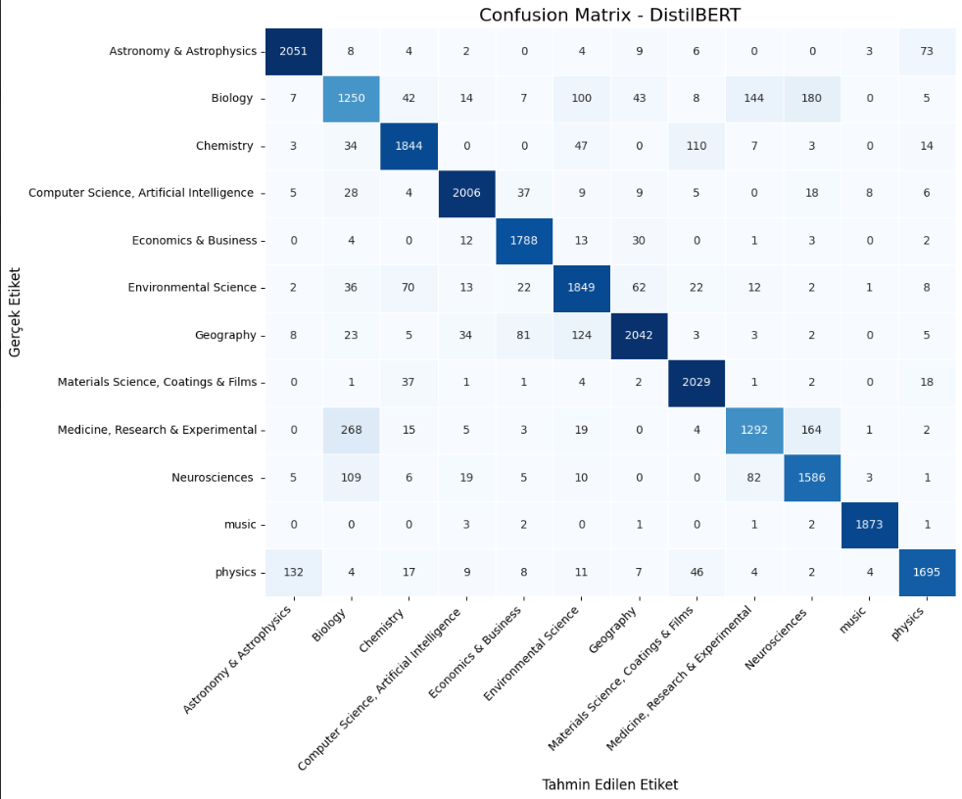

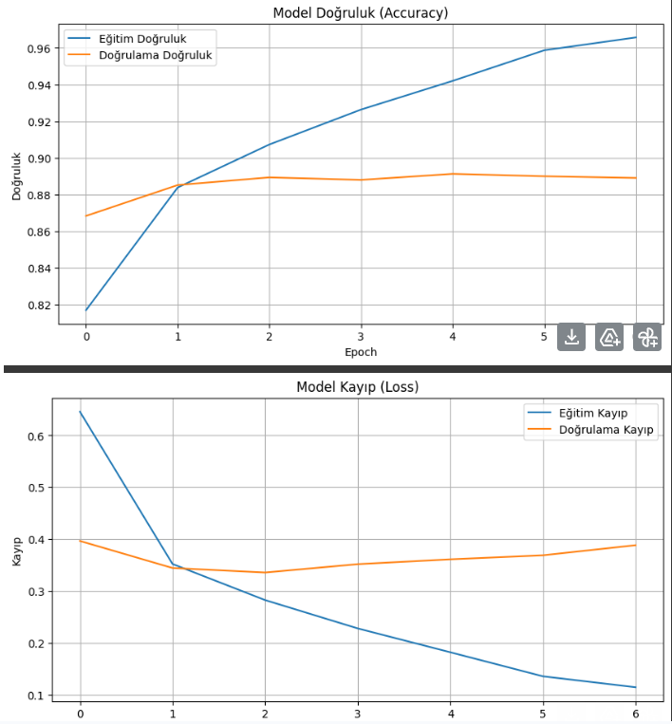

Albert Version of Classification Function

#paperdaki bert i albert ile değiştirip çalıştırdığımız kod :

import tensorflow as tf

# !!! ÖNEMLİ: Karma duyarlıklı eğitimi en başta etkinleştirin !!!
# Bu, GPU bellek kullanımını optimize eder ve A100 gibi donanımlarda performansı artırır.
tf.keras.mixed_precision.set_global_policy("mixed_float16")

# DistilBERT yerine ALBERT için gerekli importlar
from transformers import TFAlbertForSequenceClassification, AlbertTokenizer
return train_test_split(X, y, test_size=0.2, random_state=42, stratify=y)

# Adım 3: ALBERT modelini oluşturma
def create_albert_model(num_labels):
# ALBERT modelini yüklüyoruz
return TFAlbertForSequenceClassification.from_pretrained("albert-base-v2", num_labels=num_labels)

# Learning Rate Scheduler
def lr_scheduler():
return tf.keras.callbacks.ReduceLROnPlateau(
monitor='val_loss',
factor=0.5,
patience=2,
min_lr=1e-7,
verbose=1
)

# Adım 4: ALBERT modelini eğitme
def train_albert_model(model, train_data, val_data, epochs, learning_rate):
print("\nSınıflandırma Raporu (ALBERT):")
print(report)

accuracy = accuracy_score(decoded_labels, decoded_predictions)
f1_weighted = f1_score(decoded_labels, decoded_predictions, average='weighted', zero_division=0)
print(f"\nToplam Doğruluk (Accuracy): {accuracy:.4f}")
print(f"Ağırlıklı F1 Skoru: {f1_weighted:.4f}")

print("\nSınıf Başına Düşen Eleman Sayısı (Test Seti):")
unique_labels, counts = np.unique(decoded_labels, return_counts=True)
for label, count in zip(unique_labels, counts):
print(f"{label:<40} {count}")

cm = confusion_matrix(decoded_labels, decoded_predictions, labels=label_encoder.classes_)
cm_df = pd.DataFrame(cm, index=label_encoder.classes_, columns=label_encoder.classes_)

plt.figure(figsize=(12, 10))
sns.heatmap(cm_df, annot=True, fmt='d', cmap='Blues', cbar=False, linewidths=0.5)

plt.title("Confusion Matrix - ALBERT", fontsize=16)
plt.xlabel("Tahmin Edilen Etiket", fontsize=12)
plt.ylabel("Gerçek Etiket", fontsize=12)

plt.xticks(ticks=np.arange(len(label_encoder.classes_)) + 0.5,
labels=label_encoder.classes_,
rotation=45,
ha='right')

plt.yticks(ticks=np.arange(len(label_encoder.classes_)) + 0.5,
labels=label_encoder.classes_,
rotation=0)

plt.tight_layout()
plt.show()

return decoded_labels, decoded_predictions # Tahmin ve gerçek etiketleri döndür

# Yanlış sınıflandırılan örneklerin satır numaralarını bulma
def find_misclassified_examples(original_data_df, test_indices, true_labels, predicted_labels,
target_true_category, target_predicted_category):
"""
Belirli bir gerçek kategoriye sahip olup, yanlışlıkla başka bir kategoriye sınıflandırılan örneklerin
orijinal DataFrame'deki satır numaralarını bulur.

Args:
original_data_df (pd.DataFrame): Orijinal veri çerçevesi.
test_indices (np.array): Test setindeki örneklerin orijinal DataFrame'deki indeksleri.
true_labels (np.array): Test setinin gerçek etiketleri (çözülmüş).
predicted_labels (np.array): Test setinin tahmin edilen etiketleri (çözülmüş).
target_true_category (str): Gerçekte olması gereken kategori.
target_predicted_category (str): Yanlışlıkla sınıflandırılan kategori.

Returns:
list: Yanlış sınıflandırılan örneklerin orijinal DataFrame'deki satır numaralarının listesi.
"""
misclassified_indices = []
for i in range(len(true_labels)):
if true_labels[i] == target_true_category and predicted_labels[i] == target_predicted_category:
original_row_index = test_indices[i]
misclassified_indices.append(original_row_index)

return misclassified_indices

# Ana program
if __name__ == "__main__":
start_overall_time = time.time()

set_gpu_memory_growth()

file_path = '/content/drive/MyDrive/Text Classification Tez Çalışması/inputs for final task/bbc_data_Format_151K.xlsx'
try:
data = pd.read_excel(file_path)
print(f"[INFO] Veri seti başarıyla yüklendi: {file_path}")
except Exception as e:
print(f"[HATA] Veri seti yüklenirken hata oluştu: {e}")
exit()

clean_start_time = time.time()
data['text'] = data['text'].apply(clean_text)
clean_end_time = time.time()
print_metrics_and_time("Veri Temizleme", clean_start_time, clean_end_time, get_system_metrics(), "veri temizleme")

encode_start_time = time.time()
label_encoder = LabelEncoder()
data['category_encoded'] = label_encoder.fit_transform(data['category'])
encode_end_time = time.time()
print_metrics_and_time("Etiket Kodlama", encode_start_time, encode_end_time, get_system_metrics(), "etiket kodlama")

split_start_time = time.time()
X_train, X_test, y_train_encoded, y_test_encoded, train_indices, test_indices = train_test_split(
data['text'], data['category_encoded'], data.index, test_size=0.2, random_state=42, stratify=data['category']
)
split_end_time = time.time()
print_metrics_and_time("Veri Bölme", split_start_time, split_end_time, get_system_metrics(), "veri bölme")

tokenizer_start_time = time.time()
tokenizer = AlbertTokenizer.from_pretrained("albert-base-v2") # ALBERT Tokenizer
max_length = 256
batch_size = 64

train_encodings = tokenizer(list(X_train), truncation=True, padding='max_length', max_length=max_length, return_tensors="tf")
test_encodings = tokenizer(list(X_test), truncation=True, padding='max_length', max_length=max_length, return_tensors="tf")
tokenizer_end_time = time.time()
print_metrics_and_time("Tokenleştirme", tokenizer_start_time, tokenizer_end_time, get_system_metrics(), "tokenleştirme")

dataset_start_time = time.time()
train_dataset = tf.data.Dataset.from_tensor_slices({
"input_ids": train_encodings["input_ids"],
"attention_mask": train_encodings["attention_mask"],
"token_type_ids": train_encodings["token_type_ids"], # ALBERT için token_type_ids eklendi
"labels": y_train_encoded
}).batch(batch_size).prefetch(tf.data.AUTOTUNE)

test_dataset = tf.data.Dataset.from_tensor_slices({
"input_ids": test_encodings["input_ids"],
"attention_mask": test_encodings["attention_mask"],
"token_type_ids": test_encodings["token_type_ids"], # ALBERT için token_type_ids eklendi
"labels": y_test_encoded
}).batch(batch_size).prefetch(tf.data.AUTOTUNE)
dataset_end_time = time.time()
print_metrics_and_time("Dataset Oluşturma", dataset_start_time, dataset_end_time, get_system_metrics(), "dataset oluşturma")

model_creation_start_time = time.time()
albert_model = create_albert_model(num_labels=len(label_encoder.classes_))
model_creation_end_time = time.time()
print_metrics_and_time("Model Oluşturma", model_creation_start_time, model_creation_end_time, get_system_metrics(), "model oluşturma")

trained_model, history = train_albert_model(
model=albert_model,
train_data=train_dataset,
val_data=test_dataset,
epochs=10,
learning_rate=1e-5
)

evaluation_start_time = time.time()
decoded_labels, decoded_predictions = evaluate_model(
trained_model,
{"input_ids": test_encodings["input_ids"],
"attention_mask": test_encodings["attention_mask"],
"token_type_ids": test_encodings["token_type_ids"]}, # ALBERT için token_type_ids eklendi
y_test_encoded,
label_encoder
)
evaluation_end_time = time.time()
print_metrics_and_time("Model Değerlendirme", evaluation_start_time, evaluation_end_time, get_system_metrics(), "model değerlendirme")

# --- Yanlış Sınıflandırma Analizi ---
print("\n--- Yanlış Sınıflandırma Analizi ---")
misclassified_analysis_start_time = time.time()

# İstenen kategorilerle yanlış sınıflandırma analizi
misclassified_medicine_to_biology = find_misclassified_examples(
original_data_df=data,
test_indices=test_indices.to_numpy(),
true_labels=decoded_labels,
predicted_labels=decoded_predictions,
target_true_category="Medicine, Research & Experimental", # Yeni kategori adı
target_predicted_category="Biology" # Yeni kategori adı
)
print(f"Gerçekte 'Medicine, Research & Experimental' olup 'Biology' olarak sınıflandırılan örneklerin satır numaraları: {misclassified_medicine_to_biology}")
print(f"Toplam yanlış sınıflandırılan örnek sayısı (Medicine, Research & Experimental -> Biology): {len(misclassified_medicine_to_biology)}")

[INFO] GPU bellek büyümesi (memory growth) başarıyla ayarlandı.
[INFO] Veri seti başarıyla yüklendi: /content/drive/MyDrive/Text Classification Tez Çalışması/inputs for final task/bbc_data_Format_151K.xlsx

--- Veri Temizleme (veri temizleme) Metrikleri ---
İşlemci: x86_64
CPU Kullanımı: 7.2 %
RAM Kullanımı: 14.51 GB / 83.48 GB
GPU (NVIDIA A100-SXM4-40GB) Kullanım: 0.0% | Bellek: 33343.0/40960.0 MB
Gerçek Süre: 9.47 saniye
---------------------------------------

--- Etiket Kodlama (etiket kodlama) Metrikleri ---
İşlemci: x86_64
CPU Kullanımı: 6.8 %
RAM Kullanımı: 14.51 GB / 83.48 GB
GPU (NVIDIA A100-SXM4-40GB) Kullanım: 0.0% | Bellek: 33343.0/40960.0 MB
Gerçek Süre: 0.02 saniye
---------------------------------------

--- Veri Bölme (veri bölme) Metrikleri ---
İşlemci: x86_64
CPU Kullanımı: 8.3 %
RAM Kullanımı: 14.49 GB / 83.48 GB
GPU (NVIDIA A100-SXM4-40GB) Kullanım: 0.0% | Bellek: 33343.0/40960.0 MB
Gerçek Süre: 0.10 saniye
---------------------------------------
tokenizer_config.json: 100%
25.0/25.0 [00:00<00:00, 3.15kB/s]
spiece.model: 100%
760k/760k [00:00<00:00, 1.74MB/s]
tokenizer.json: 100%
1.31M/1.31M [00:00<00:00, 6.25MB/s]
config.json: 100%
684/684 [00:00<00:00, 78.2kB/s]
--- Tokenleştirme (tokenleştirme) Metrikleri ---
İşlemci: x86_64
CPU Kullanımı: 10.3 %
RAM Kullanımı: 14.67 GB / 83.48 GB
GPU (NVIDIA A100-SXM4-40GB) Kullanım: 0.0% | Bellek: 33343.0/40960.0 MB
Gerçek Süre: 196.19 saniye
---------------------------------------

--- Dataset Oluşturma (dataset oluşturma) Metrikleri ---
İşlemci: x86_64
CPU Kullanımı: 8.5 %
RAM Kullanımı: 14.68 GB / 83.48 GB
GPU (NVIDIA A100-SXM4-40GB) Kullanım: 0.0% | Bellek: 33343.0/40960.0 MB
Gerçek Süre: 0.01 saniye
---------------------------------------
model.safetensors: 100%
47.4M/47.4M [00:01<00:00, 35.7MB/s]
All PyTorch model weights were used when initializing TFAlbertForSequenceClassification.

Some weights or buffers of the TF 2.0 model TFAlbertForSequenceClassification were not initialized from the PyTorch model and are newly initialized: ['classifier.weight', 'classifier.bias']
You should probably TRAIN this model on a down-stream task to be able to use it for predictions and inference.
--- Model Oluşturma (model oluşturma) Metrikleri ---
İşlemci: x86_64
CPU Kullanımı: 11.6 %
RAM Kullanımı: 14.69 GB / 83.48 GB
GPU (NVIDIA A100-SXM4-40GB) Kullanım: 0.0% | Bellek: 33343.0/40960.0 MB
Gerçek Süre: 2.18 saniye
---------------------------------------

--- Model Derleme İşlemi Başlıyor ---

--- Derleme (kod derleme) Metrikleri ---
İşlemci: x86_64
CPU Kullanımı: 7.7 %
RAM Kullanımı: 14.69 GB / 83.48 GB
GPU (NVIDIA A100-SXM4-40GB) Kullanım: 0.0% | Bellek: 33343.0/40960.0 MB
Gerçek Süre: 0.02 saniye
---------------------------------------

--- Model Eğitim İşlemi Başlıyor ---
Epoch 1/10
1498/1498 [==============================] - 490s 315ms/step - loss: 0.6456 - accuracy: 0.7958 - val_loss: 0.4741 - val_accuracy: 0.8420 - lr: 1.0000e-05
Epoch 2/10
1498/1498 [==============================] - 427s 285ms/step - loss: 0.4011 - accuracy: 0.8653 - val_loss: 0.4262 - val_accuracy: 0.8601 - lr: 1.0000e-05
Epoch 3/10
1498/1498 [==============================] - 426s 285ms/step - loss: 0.3538 - accuracy: 0.8811 - val_loss: 0.3857 - val_accuracy: 0.8693 - lr: 1.0000e-05
Epoch 4/10
1498/1498 [==============================] - 428s 286ms/step - loss: 0.2976 - accuracy: 0.9007 - val_loss: 0.3762 - val_accuracy: 0.8734 - lr: 1.0000e-05
Epoch 5/10
1498/1498 [==============================] - 427s 285ms/step - loss: 0.2535 - accuracy: 0.9162 - val_loss: 0.3892 - val_accuracy: 0.8726 - lr: 1.0000e-05
Epoch 6/10
1498/1498 [==============================] - ETA: 0s - loss: 0.2104 - accuracy: 0.9318
Epoch 6: ReduceLROnPlateau reducing learning rate to 4.999999873689376e-06.
1498/1498 [==============================] - 426s 284ms/step - loss: 0.2104 - accuracy: 0.9318 - val_loss: 0.3953 - val_accuracy: 0.8733 - lr: 1.0000e-05
Epoch 7/10
1498/1498 [==============================] - 426s 285ms/step - loss: 0.1628 - accuracy: 0.9477 - val_loss: 0.3888 - val_accuracy: 0.8783 - lr: 5.0000e-06
Epoch 8/10
1498/1498 [==============================] - ETA: 0s - loss: 0.1215 - accuracy: 0.9645
Epoch 8: ReduceLROnPlateau reducing learning rate to 2.499999936844688e-06.
1498/1498 [==============================] - 426s 285ms/step - loss: 0.1215 - accuracy: 0.9645 - val_loss: 0.4167 - val_accuracy: 0.8761 - lr: 5.0000e-06
Epoch 8: early stopping
Restoring model weights from the end of the best epoch: 4.

--- Eğitim (model eğitim) Metrikleri ---
İşlemci: x86_64
CPU Kullanımı: 9.1 %
RAM Kullanımı: 14.69 GB / 83.48 GB
GPU (NVIDIA A100-SXM4-40GB) Kullanım: 2.0% | Bellek: 33343.0/40960.0 MB
Gerçek Süre: 3477.20 saniye
---------------------------------------
749/749 [==============================] - 46s 57ms/step

Sınıflandırma Raporu (ALBERT):
precision recall f1-score support

Astronomy & Astrophysics 0.93 0.93 0.93 2160
Biology 0.67 0.68 0.67 1800
Chemistry 0.88 0.88 0.88 2062
Computer Science, Artificial Intelligence 0.90 0.96 0.93 2135
Economics & Business 0.90 0.96 0.93 1853
Environmental Science 0.90 0.77 0.83 2099
Geography 0.90 0.87 0.89 2330
Materials Science, Coatings & Films 0.91 0.95 0.93 2096
Medicine, Research & Experimental 0.82 0.69 0.75 1773
Neurosciences 0.77 0.88 0.82 1826
music 0.99 0.99 0.99 1883
physics 0.88 0.89 0.89 1939

accuracy 0.87 23956
macro avg 0.87 0.87 0.87 23956
weighted avg 0.87 0.87 0.87 23956

Toplam Doğruluk (Accuracy): 0.8734
Ağırlıklı F1 Skoru: 0.8723

Sınıf Başına Düşen Eleman Sayısı (Test Seti):
Astronomy & Astrophysics 2160
Biology 1800
Chemistry 2062
Computer Science, Artificial Intelligence 2135
Economics & Business 1853
Environmental Science 2099
Geography 2330
Materials Science, Coatings & Films 2096
Medicine, Research & Experimental 1773
Neurosciences 1826
music 1883
physics 1939

--- Model Değerlendirme (model değerlendirme) Metrikleri ---
İşlemci: x86_64
CPU Kullanımı: 8.2 %
RAM Kullanımı: 14.79 GB / 83.48 GB
GPU (NVIDIA A100-SXM4-40GB) Kullanım: 0.0% | Bellek: 33353.0/40960.0 MB
Gerçek Süre: 47.21 saniye
---------------------------------------

--- Yanlış Sınıflandırma Analizi ---
Gerçekte 'Medicine, Research & Experimental' olup 'Biology' olarak sınıflandırılan örneklerin satır numaraları: []
Toplam yanlış sınıflandırılan örnek sayısı (Medicine, Research & Experimental -> Biology): 0

--- Yanlış Sınıflandırma Analizi (analiz) Metrikleri ---
İşlemci: x86_64
CPU Kullanımı: 16.0 %
RAM Kullanımı: 14.79 GB / 83.48 GB
GPU (NVIDIA A100-SXM4-40GB) Kullanım: 0.0% | Bellek: 33353.0/40960.0 MB
Gerçek Süre: 0.00 saniye
---------------------------------------

[INFO] Tüm Programın Toplam Çalışma Süresi: 3741.39 saniye
[INFO] Tüm Programın Toplam Çalışma Süresi (HH:MM:SS): 01:02:21
[INFO] Program başarıyla tamamlandı.
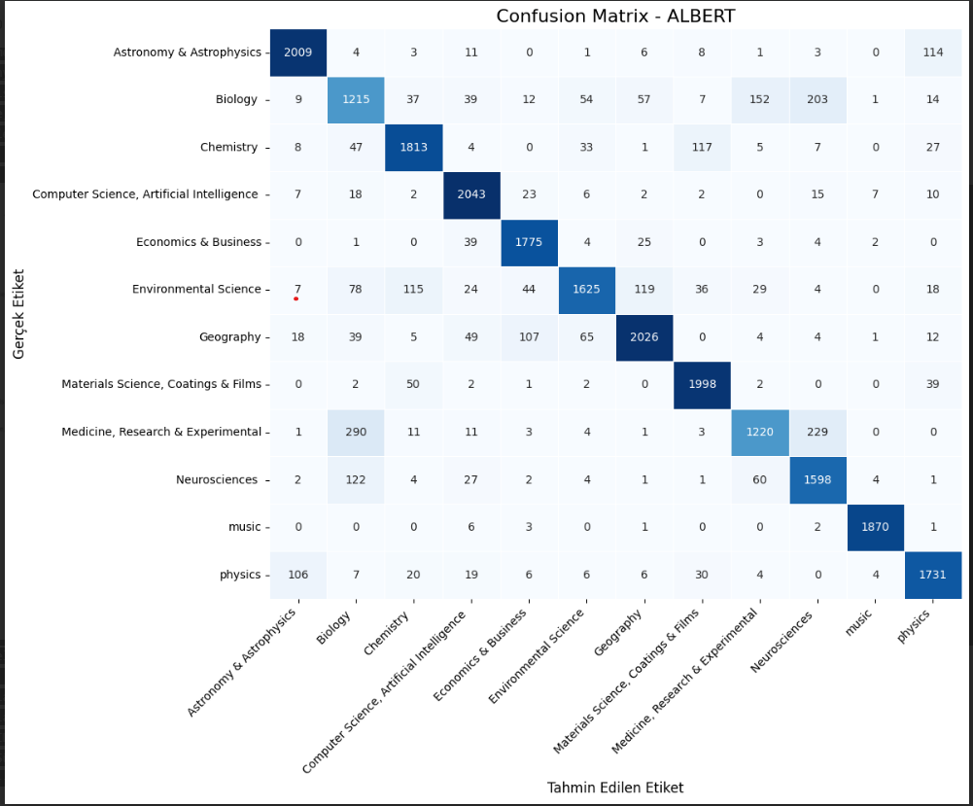

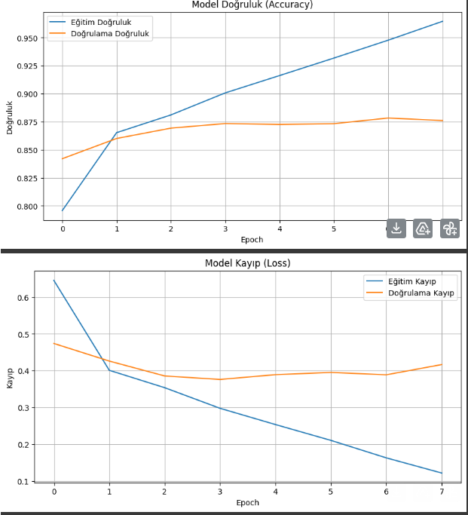

Scibert (Kfold) Version of Classification Function
#kfold scibert version

!pip install gputil

import os

# Keras'ın eski (legacy) versiyonunu kullanmaya zorla
os.environ["TF_USE_LEGACY_KERAS"] = "1"

import tensorflow as tf
from tensorflow.keras.optimizers import AdamW
from transformers import AutoTokenizer, TFAutoModelForSequenceClassification
from sklearn.model_selection import StratifiedKFold
from sklearn.preprocessing import LabelEncoder
from sklearn.metrics import classification_report, confusion_matrix
import pandas as pd
import numpy as np
import re
import matplotlib.pyplot as plt
import seaborn as sns
import time
import psutil
import GPUtil
import platform

# GPU bellek kullanımını optimize etme
gpus = tf.config.list_physical_devices('GPU')
if gpus:
try:
for gpu in gpus:
tf.config.experimental.set_memory_growth(gpu, True)
logical_gpus = tf.config.experimental.list_logical_devices('GPU')
print(f"{len(gpus)} Physical GPUs, {len(logical_gpus)} Logical GPUs")
except RuntimeError as e:
print(e)

# Karma duyarlıklı eğitimi etkinleştirin
tf.keras.mixed_precision.set_global_policy("mixed_float16")

# Adım 1: Veriyi temizleyen fonksiyon
def clean_text(text):
text = re.sub(r'[^\w\s]', '', text)
text = re.sub(r'\s+', ' ', text)
text = text.lower()
return text

# Adım 2: SciBERT modelini oluşturma fonksiyonu
def create_scibert_model(num_labels):
model = TFAutoModelForSequenceClassification.from_pretrained(
"allenai/scibert_scivocab_uncased",
num_labels=num_labels,
from_pt=True
)
return model

# Learning Rate Scheduler
def lr_scheduler():
return tf.keras.callbacks.ReduceLROnPlateau(
monitor='val_loss', factor=0.5, patience=3, min_lr=1e-7, verbose=1
)

# Adım 3: SciBERT modelini eğitme fonksiyonu
def train_scibert_model(model, train_data, val_data, epochs, learning_rate):
optimizer = AdamW(learning_rate=learning_rate)
loss_fn = tf.keras.losses.SparseCategoricalCrossentropy(from_logits=True)

model.compile(optimizer=optimizer, loss=loss_fn, metrics=["accuracy"])

scheduler = lr_scheduler()
early_stopping = tf.keras.callbacks.EarlyStopping(
monitor='val_loss', patience=4, restore_best_weights=True, verbose=1
)

callbacks_list = [scheduler, early_stopping]

model.fit(train_data, validation_data=val_data, epochs=epochs,
callbacks=callbacks_list, verbose=1)
return model

# Adım 4: Modeli değerlendirme fonksiyonu
def evaluate_model(model, val_data, val_labels_encoded, label_encoder):
predictions = model.predict(val_data).logits
predicted_labels_encoded = np.argmax(predictions, axis=1)

decoded_labels = label_encoder.inverse_transform(val_labels_encoded)
decoded_predictions = label_encoder.inverse_transform(predicted_labels_encoded)

report = classification_report(decoded_labels, decoded_predictions,
target_names=label_encoder.classes_, zero_division=0)
print("Sınıflandırma Raporu (SciBERT):")
print(report)

cm = confusion_matrix(decoded_labels, decoded_predictions, labels=label_encoder.classes_)
cm_df = pd.DataFrame(cm, index=label_encoder.classes_, columns=label_encoder.classes_)

plt.figure(figsize=(12, 10))
sns.heatmap(cm_df, annot=True, fmt='d', cmap='Blues', cbar=False, linewidths=0.5)
plt.title("Confusion Matrix - SciBERT", fontsize=16)
plt.xlabel("Tahmin Edilen Etiket", fontsize=12)
plt.ylabel("Gerçek Etiket", fontsize=12)
plt.xticks(ticks=np.arange(len(label_encoder.classes_)) + 0.5, labels=label_encoder.classes_, rotation=45, ha='right')
plt.yticks(ticks=np.arange(len(label_encoder.classes_)) + 0.5, labels=label_encoder.classes_, rotation=0)
plt.tight_layout()
plt.show()

# Ana program
if __name__ == "__main__":
start_time = time.time()

file_path = '/content/drive/MyDrive/Text Classification Tez Çalışması/inputs for final task/bbc_data_Format_151K.xlsx'
data = pd.read_excel(file_path)
data['text'] = data['text'].apply(clean_text)

label_encoder = LabelEncoder()
data['category_encoded'] = label_encoder.fit_transform(data['category'])

tokenizer = AutoTokenizer.from_pretrained("allenai/scibert_scivocab_uncased")
max_length = 384

save_dir = '/content/drive/MyDrive/scibert_kfold_checkpoints'
os.makedirs(save_dir, exist_ok=True)

completed_folds_file = os.path.join(save_dir, 'completed_folds.txt')
completed_folds = set()
if os.path.exists(completed_folds_file):
with open(completed_folds_file, 'r') as f:
for line in f:
try:
completed_folds.add(int(line.strip()))
except ValueError:
continue
print(f"Daha önce tamamlanmış foldlar: {sorted(list(completed_folds))}")

# K-Fold döngüsü dışında modeli bir kez oluştur
print("\nModel ana ağırlıkları oluşturuluyor...")
base_model = create_scibert_model(num_labels=len(label_encoder.classes_))
# İlk haliyle ağırlıklarını kaydet
initial_weights = base_model.get_weights()

kf = StratifiedKFold(n_splits=5, shuffle=True, random_state=42)

for fold, (train_idx, val_idx) in enumerate(kf.split(data['text'], data['category_encoded']), 1):
if fold in completed_folds:
print(f"\n--- Fold {fold} zaten tamamlanmış, atlanıyor. ---")
continue

print(f"\n=== Fold {fold} ===")
X_train, X_val = data['text'].iloc[train_idx], data['text'].iloc[val_idx]
y_train, y_val = data['category_encoded'].iloc[train_idx], data['category_encoded'].iloc[val_idx]

train_encodings = tokenizer(
list(X_train), truncation=True, padding='max_length',
max_length=max_length, return_tensors="tf"
)
val_encodings = tokenizer(
list(X_val), truncation=True, padding='max_length',
max_length=max_length, return_tensors="tf"
)

BUFFER_SIZE = tf.data.AUTOTUNE
BATCH_SIZE = 32

train_dataset = tf.data.Dataset.from_tensor_slices((
{"input_ids": train_encodings["input_ids"],
"attention_mask": train_encodings["attention_mask"]},
y_train
)).shuffle(len(y_train)).batch(BATCH_SIZE).prefetch(BUFFER_SIZE)

val_dataset = tf.data.Dataset.from_tensor_slices((
{"input_ids": val_encodings["input_ids"],
"attention_mask": val_encodings["attention_mask"]},
y_val
)).batch(BATCH_SIZE).prefetch(BUFFER_SIZE)

# Her fold için modeli yeniden başlatmak yerine, ana ağırlıkları yükle
model_for_fold = create_scibert_model(num_labels=len(label_encoder.classes_))
model_for_fold.set_weights(initial_weights)

trained_model = train_scibert_model(model_for_fold, train_dataset, val_dataset,
epochs=10, learning_rate=2e-5)

evaluate_model(trained_model,
{"input_ids": val_encodings["input_ids"],
"attention_mask": val_encodings["attention_mask"]},
y_val, label_encoder)

model_save_path = os.path.join(save_dir, f'scibert_fold_{fold}_weights.h5')
trained_model.save_weights(model_save_path)
print(f"Fold {fold} modeli ağırlıkları '{model_save_path}' konumuna kaydedildi.")

with open(completed_folds_file, 'a') as f:
f.write(f"{fold}\n")
completed_folds.add(fold)

end_time = time.time()
total_time = time.strftime('%H:%M:%S', time.gmtime(end_time - start_time))
print(f"\nToplam Eğitim Süreci: {total_time}")
print("\nDonanım Bilgileri:")
print(f"CPU: {platform.processor()}")
print(f"CPU Kullanımı: {psutil.cpu_percent()} %")
mem = psutil.virtual_memory()
print(f"RAM: {round(mem.total / (1024**3), 2)} GB (Kullanılan: {round(mem.used / (1024**3), 2)} GB, Oran: {mem.percent}%)")
gpus = GPUtil.getGPUs()
if gpus:
for gpu in gpus:
print(f"GPU: {gpu.name} | Kullanım: {gpu.load*100:.1f}% | Bellek: {gpu.memoryUsed}/{gpu.memoryTotal} MB")
else:
print("GPU: Kullanılamıyor veya tanımlı değil.")
Requirement already satisfied: gputil in /usr/local/lib/python3.11/dist-packages (1.4.0)
1 Physical GPUs, 1 Logical GPUs
/usr/local/lib/python3.11/dist-packages/huggingface_hub/utils/_auth.py:94: UserWarning:
The secret `HF_TOKEN` does not exist in your Colab secrets.
To authenticate with the Hugging Face Hub, create a token in your settings tab (https://huggingface.co/settings/tokens), set it as secret in your Google Colab and restart your session.
You will be able to reuse this secret in all of your notebooks.
Please note that authentication is recommended but still optional to access public models or datasets.
warnings.warn(
Daha önce tamamlanmış foldlar: []

Model ana ağırlıkları oluşturuluyor...
TensorFlow and JAX classes are deprecated and will be removed in Transformers v5. We recommend migrating to PyTorch classes or pinning your version of Transformers.
All PyTorch model weights were used when initializing TFBertForSequenceClassification.

Some weights or buffers of the TF 2.0 model TFBertForSequenceClassification were not initialized from the PyTorch model and are newly initialized: ['classifier.weight', 'classifier.bias']
You should probably TRAIN this model on a down-stream task to be able to use it for predictions and inference.
TensorFlow and JAX classes are deprecated and will be removed in Transformers v5. We recommend migrating to PyTorch classes or pinning your version of Transformers.
=== Fold 1 ===
All PyTorch model weights were used when initializing TFBertForSequenceClassification.

Some weights or buffers of the TF 2.0 model TFBertForSequenceClassification were not initialized from the PyTorch model and are newly initialized: ['classifier.weight', 'classifier.bias']
You should probably TRAIN this model on a down-stream task to be able to use it for predictions and inference.
Epoch 1/10
2995/2995 [==============================] - 923s 289ms/step - loss: 0.3803 - accuracy: 0.8783 - val_loss: 0.2726 - val_accuracy: 0.9082 - lr: 2.0000e-05
Epoch 2/10
2995/2995 [==============================] - 812s 271ms/step - loss: 0.2136 - accuracy: 0.9286 - val_loss: 0.2442 - val_accuracy: 0.9179 - lr: 2.0000e-05
Epoch 3/10
2995/2995 [==============================] - 809s 270ms/step - loss: 0.1347 - accuracy: 0.9562 - val_loss: 0.2633 - val_accuracy: 0.9175 - lr: 2.0000e-05
Epoch 4/10
2995/2995 [==============================] - 809s 270ms/step - loss: 0.0813 - accuracy: 0.9738 - val_loss: 0.3129 - val_accuracy: 0.9148 - lr: 2.0000e-05
Epoch 5/10
2995/2995 [==============================] - ETA: 0s - loss: 0.0553 - accuracy: 0.9826
Epoch 5: ReduceLROnPlateau reducing learning rate to 9.999999747378752e-06.
2995/2995 [==============================] - 814s 272ms/step - loss: 0.0553 - accuracy: 0.9826 - val_loss: 0.3101 - val_accuracy: 0.9178 - lr: 2.0000e-05
Epoch 6/10
2995/2995 [==============================] - 809s 270ms/step - loss: 0.0248 - accuracy: 0.9928 - val_loss: 0.3692 - val_accuracy: 0.9192 - lr: 1.0000e-05
Epoch 6: early stopping
Restoring model weights from the end of the best epoch: 2.
749/749 [==============================] - 62s 79ms/step
Sınıflandırma Raporu (SciBERT):
precision recall f1-score support

Astronomy & Astrophysics 0.94 0.98 0.96 2161
Biology 0.79 0.79 0.79 1799
Chemistry 0.95 0.89 0.92 2062
Computer Science, Artificial Intelligence 0.95 0.97 0.96 2135
Economics & Business 0.97 0.94 0.95 1853
Environmental Science 0.87 0.92 0.89 2099
Geography 0.94 0.90 0.92 2331
Materials Science, Coatings & Films 0.92 0.97 0.95 2095
Medicine, Research & Experimental 0.89 0.82 0.86 1773
Neurosciences 0.85 0.91 0.88 1825
music 0.99 1.00 0.99 1884
physics 0.94 0.90 0.92 1939

accuracy 0.92 23956
macro avg 0.92 0.92 0.92 23956
weighted avg 0.92 0.92 0.92 23956

​ 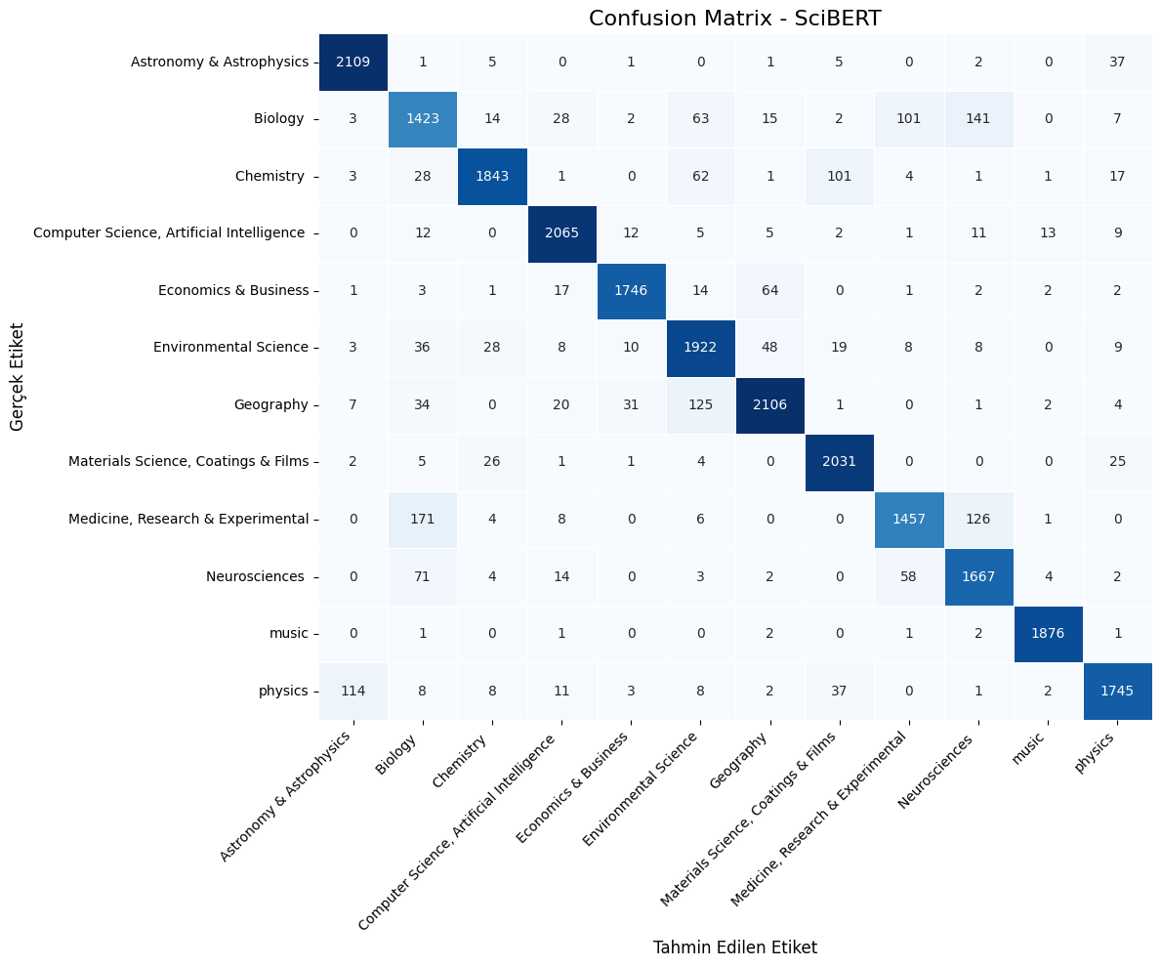

​Fold 1 modeli ağırlıkları '/content/drive/MyDrive/scibert_kfold_checkpoints/scibert_fold_1_weights.h5' konumuna kaydedildi.

Scibert (Kfold) &FAISS&Dual Encoder&Siamese&SentenceTransformer&L2Normalisation&Cosine_Full_Pipeline

# Full integrated pipeline (MEMORY-SAFE, CATEGORY-NORMALIZED, )
# SciBERT + Dual-Encoder + FAISS
# Requirements: !pip install -U sentence-transformers transformers faiss-cpu scikit-learn gradio

import os, re, time, logging, warnings
from typing import List, Tuple, Dict
import numpy as np
import pandas as pd
import torch
import faiss
from tqdm.auto import tqdm
import difflib

import tensorflow as tf
os.environ["TF_USE_LEGACY_KERAS"] = "1"

from sentence_transformers import SentenceTransformer, util
from sklearn.preprocessing import LabelEncoder
from sklearn.linear_model import LogisticRegression
from transformers import AutoTokenizer, TFAutoModelForSequenceClassification
import gradio as gr

warnings.filterwarnings("ignore", category=UserWarning)
logging.basicConfig(level=logging.INFO)

# ---------------- CONFIG ----------------
SAVE_DIR = "/content/drive/MyDrive/dual_encoder_checkpoints"
PROCESSED_DATA_PATH = "/content/drive/MyDrive/Text Classification Tez Çalışması/inputs for final task/processed_journals_Full.csv"

SCIBERT_MODEL_NAME = "allenai/scibert_scivocab_uncased"
SCIBERT_WEIGHTS_PATH = os.path.join("/content/drive/MyDrive/scibert_kfold_checkpoints",
"scibert_fold_1_weights.h5")

TRAINING_CATEGORIES = [
'Astronomy & Astrophysics',
'Biology',
'Chemistry',
'Computer Science, Artificial Intelligence',
'Economics & Business',
'Environmental Science',
'Geography',
'Materials Science, Coatings & Films',
'Medicine, Research & Experimental',
'Neurosciences',
'music',
'physics'
]

# Memory / batching knobs (minimal, safe changes)
ENCODER_BATCH_SIZE = 128 # used for encoder.encode; adaptive retry will lower if OOM
TRAIN_MICRO_BATCH = 64 # micro-batch for gradient accumulation
EFFECTIVE_TRAIN_BATCH = 256 # desired effective batch size (kept for performance)
NUM_EPOCHS = 3
LR = 2e-5
TEMPERATURE = 20.0
TOP_K = 20
MIN_TOKENS = 20
DEVICE = "cuda" if torch.cuda.is_available() else "cpu"
RANDOM_STATE = 42

os.makedirs(SAVE_DIR, exist_ok=True)
np.random.seed(RANDOM_STATE)
torch.manual_seed(RANDOM_STATE)

# ---------------- Utilities ----------------
def clean_text(text: str) -> str:
if not isinstance(text, str):
return ""
t = text.strip()
t = re.sub(r'<.*?>', ' ', t)
t = re.sub(r'\s+', ' ', t)
return t

def normalize_category_name(cat: str) -> str:
# strip, collapse spaces
if not isinstance(cat, str):
return cat
c = re.sub(r'\s+', ' ', cat).strip()
return c

def map_categories_to_training(df: pd.DataFrame, training_classes: List[str]) -> Tuple[pd.DataFrame, Dict[str,str]]:
"""
Normalize categories in df and map unknown variants to the nearest training class when possible.
Returns modified df and a mapping dict (original -> mapped).
"""
df['category'] = df['category'].astype(str).apply(normalize_category_name)

training_lower = {c.lower(): c for c in training_classes}
mapping = {}

uniques = sorted(df['category'].dropna().unique())

for u in uniques:
if u in training_classes:
mapping[u] = u
continue
# exact lowercase match
if u.lower() in training_lower:
mapping[u] = training_lower[u.lower()]
continue
# fuzzy match (conservative cutoff)
matches = difflib.get_close_matches(u, training_classes, n=1, cutoff=0.82)
if matches:
mapping[u] = matches[0]
logging.info(f"Mapping dataset category '{u}' -> '{matches[0]}' (fuzzy)")
continue
# no good match -> leave as-is but log warning
mapping[u] = u
logging.warning(f"No mapping for dataset category '{u}'. It will remain as-is."
" If this should map to one of TRAINING_CATEGORIES, please check spelling/casing.")

df['category'] = df['category'].map(mapping)
return df, mapping

def read_and_prepare(path: str, min_words: int = MIN_TOKENS) -> pd.DataFrame:
if not os.path.exists(path):
raise FileNotFoundError(f"{path} bulunamadı.")

df = pd.read_csv(path)
required = {'abstract', 'jurnal_rep', 'category'}
if not required.issubset(set(df.columns)):
raise ValueError(f"CSV must contain columns: {required}")

df = df[['abstract', 'jurnal_rep', 'category']].dropna().reset_index(drop=True)
df['abstract'] = df['abstract'].astype(str).apply(clean_text)
df['n_words'] = df['abstract'].apply(lambda s: len(s.split()))
df = df[df['n_words'] >= min_words].copy()
df = df.reset_index(drop=True)

logging.info(f"Prepared data: {len(df)} abstracts (min_words={min_words}). "
f"Unique journals: {df['jurnal_rep'].nunique()}")
return df

# ---------------- Robust/Adaptive Embedding ----------------
def compute_abs_embeddings(encoder: SentenceTransformer, texts: List[str],
device: str = DEVICE, batch_size: int = ENCODER_BATCH_SIZE) -> np.ndarray:
"""
Compute sentence embeddings with adaptive OOM handling: if OOM occurs, reduce batch_size and retry.
"""
cur_bs = batch_size
last_exc = None
while cur_bs >= 8:
try:
embs = encoder.encode(texts, convert_to_numpy=True, show_progress_bar=True,
device=device, batch_size=cur_bs)
norms = np.linalg.norm(embs, axis=1, keepdims=True)
norms[norms == 0] = 1.0
embs = embs / norms
return embs.astype('float32')
except RuntimeError as e:
last_exc = e
msg = str(e).lower()
if 'out of memory' in msg or 'cuda' in msg:
logging.warning(f"OOM during encode with batch_size={cur_bs}. Reducing batch and retrying.")
try:
torch.cuda.empty_cache()
except Exception:
pass
cur_bs = cur_bs // 2
continue
else:
raise
# if we exit loop
logging.error("Unable to compute embeddings without OOM. Last exception:\n%s", last_exc)
raise last_exc

# ---------------- Journal Embeddings ----------------
def build_journal_mean_embeddings(abs_embs: np.ndarray, journals: List[str],
categories: List[str]) -> Tuple[np.ndarray, List[str], Dict[str,str]]:
uniq_journals = sorted(list(set(journals)))
idxs_by_j = {j: [] for j in uniq_journals}
for idx, j in enumerate(journals):
idxs_by_j[j].append(idx)

journal_embs = []
journal_list = []
journal_to_category = {}

for j in uniq_journals:
indices = idxs_by_j[j]
if len(indices) == 0:
continue

mat = abs_embs[indices, :].astype('float32')
mean_vec = np.mean(mat, axis=0)
mean_vec = mean_vec / (np.linalg.norm(mean_vec) + 1e-12)

journal_embs.append(mean_vec.astype('float32'))
journal_list.append(j)

cats = [categories[i] for i in indices]
rep_cat = max(set(cats), key=cats.count)
journal_to_category[j] = rep_cat

M = np.stack(journal_embs, axis=0) if len(journal_embs)>0 else np.zeros((0, abs_embs.shape[1]), dtype='float32')
logging.info(f"Built journal matrix: shape {M.shape}")
return M, journal_list, journal_to_category

# ---------------- Dual Encoder Training (Accumulation) ----------------
class DualEncoderTrainer:
def __init__(self, encoder: SentenceTransformer, journal_matrix: np.ndarray,
journal_list: List[str], device: str = DEVICE):
self.encoder = encoder
self.encoder.to(device)
self.device = device
self.journal_matrix = torch.tensor(journal_matrix, dtype=torch.float32, device=device)
self.journal_list = journal_list
self.n_journals = self.journal_matrix.size(0)
self.dim = self.journal_matrix.size(1)
logging.info(f"Trainer init: n_journals={self.n_journals}, dim={self.dim}, device={self.device}")

def _texts_to_features(self, texts: List[str]):
sentence_features = self.encoder.tokenize(texts)
util.batch_to_device(sentence_features, torch.device(self.device))
return sentence_features

def train(self, abstracts: List[str], journal_indices: List[int],
micro_batch_size: int = TRAIN_MICRO_BATCH, effective_batch_size: int = EFFECTIVE_TRAIN_BATCH,
epochs: int = NUM_EPOCHS, lr: float = LR, temperature: float = TEMPERATURE, save_path: str = None):
dataset_size = len(abstracts)
assert dataset_size == len(journal_indices)

parameters = list(self.encoder.parameters())
optimizer = torch.optim.AdamW(parameters, lr=lr)
loss_fn = torch.nn.CrossEntropyLoss()

accumulation_steps = max(1, effective_batch_size // micro_batch_size)

self.encoder.train()

for epoch in range(1, epochs + 1):
start = time.time()
data_idx = np.arange(dataset_size)
np.random.shuffle(data_idx)
total_loss = 0.0
n_steps = 0
opt_steps = 0

for s in range(0, dataset_size, micro_batch_size):
batch_idx = data_idx[s:s+micro_batch_size]
batch_texts = [abstracts[i] for i in batch_idx]
batch_j_idxs = [journal_indices[i] for i in batch_idx]
bsz = len(batch_texts)

if bsz == 0:
continue

try:
sentence_features = self._texts_to_features(batch_texts)
model_output = self.encoder(sentence_features)
emb = model_output['sentence_embedding']
emb = torch.nn.functional.normalize(emb, p=2, dim=1)

pos_vectors = self.journal_matrix[torch.tensor(batch_j_idxs, dtype=torch.long, device=self.device), :]
pos_vectors = torch.nn.functional.normalize(pos_vectors, p=2, dim=1)

logits = torch.matmul(emb, pos_vectors.t()) * (temperature / 1.0)
targets = torch.arange(bsz, dtype=torch.long, device=self.device)

loss = loss_fn(logits, targets)
loss = loss / accumulation_steps
loss.backward()

except RuntimeError as e:
msg = str(e).lower()
if 'out of memory' in msg or 'cuda' in msg:
logging.warning("OOM during training micro-batch. Emptying cache and continuing.")
try:
torch.cuda.empty_cache()
except Exception:
pass
continue
else:
raise

n_steps += 1

if n_steps % accumulation_steps == 0:
optimizer.step()
optimizer.zero_grad()
opt_steps += 1

total_loss += float(loss.detach().cpu().item()) * accumulation_steps # scale back

# final step if gradients remain
if n_steps % accumulation_steps != 0:
optimizer.step()
optimizer.zero_grad()
opt_steps += 1

avg_loss = total_loss / max(1, n_steps)
elapsed = time.time() - start
logging.info(f"Epoch {epoch}/{epochs} — loss={avg_loss:.6f} time={elapsed:.1f}s steps={opt_steps}")

if save_path:
try:
self.encoder.save(save_path)
logging.info(f"Encoder saved to {save_path}")
except Exception as e:
logging.warning(f"Could not save encoder: {e}")

return self.encoder

# ---------------- FAISS index per-category ----------------
def build_faiss_indices_per_category(journal_matrix: np.ndarray, journal_list: List[str],
journal_to_category: Dict[str,str]) -> Dict[str, Dict]:
j_to_idx = {j: i for i,j in enumerate(journal_list)}
cat_to_idxs = {}

for j, cat in journal_to_category.items():
if j not in j_to_idx:
continue
cat_to_idxs.setdefault(cat, []).append(j_to_idx[j])

cat_indices = {}
for cat, idxs in cat_to_idxs.items():
if len(idxs) == 0:
continue

M_cat = journal_matrix[np.array(idxs, dtype=int), :].astype('float32')
norms = np.linalg.norm(M_cat, axis=1, keepdims=True)
norms[norms==0] = 1.0
M_cat = M_cat / norms

dim = M_cat.shape[1]
index = faiss.IndexFlatIP(dim)
index.add(M_cat)

journals_cat = [journal_list[i] for i in idxs]
cat_indices[cat] = {
'index': index,
'matrix': M_cat,
'journals': journals_cat
}
logging.info(f"Built FAISS index for category '{cat}' with {len(journals_cat)} journals.")

return cat_indices

# ---------------- Inference helper for FAISS ----------------
def search_topk_in_category(encoder: SentenceTransformer, cat_index_struct: Dict,
query: str, top_k: int = TOP_K, device: str = DEVICE):
q_clean = clean_text(query)
try:
q_emb = encoder.encode([q_clean], convert_to_numpy=True, device=device)
except TypeError:
q_emb = encoder.encode([q_clean], convert_to_numpy=True)

q_emb = np.array(q_emb, dtype='float32')
q_emb = q_emb / (np.linalg.norm(q_emb, axis=1, keepdims=True) + 1e-12)

D, I = cat_index_struct['index'].search(q_emb.astype('float32'),
min(top_k, cat_index_struct['matrix'].shape[0]))

results = []
for idx, score in zip(I[0], D[0]):
results.append((cat_index_struct['journals'][idx], float(score)))

return results

# ---------------- SciBERT prediction helper ----------------
def predict_category_with_scibert(text: str, tokenizer: AutoTokenizer,
model: TFAutoModelForSequenceClassification,
label_encoder: LabelEncoder, debug: bool = False):
text_clean = clean_text(text)
inputs = tokenizer([text_clean], truncation=True, padding='max_length',
max_length=384, return_tensors='tf')

outputs = model(inputs)
logits = outputs.logits.numpy()[0]

if debug:
logging.info(f"Logits shape: {logits.shape}")
logging.info(f"Label encoder classes: {label_encoder.classes_}")
probs = tf.nn.softmax(logits).numpy()
top3_idx = np.argsort(probs)[-3:][::-1]
logging.info(f"Top 3 predictions:")
for idx in top3_idx:
logging.info(f" {label_encoder.classes_[idx]}: {probs[idx]:.4f}")

pred_idx = int(np.argmax(logits))

if pred_idx >= len(label_encoder.classes_):
logging.error(f"❌ Pred index {pred_idx} >= num_classes {len(label_encoder.classes_)}")
return None

pred_label = label_encoder.inverse_transform([pred_idx])[0]

if debug:
logging.info(f"✓ Predicted category: {pred_label}")

return pred_label

# ---------------- Performance Evaluation ----------------
def evaluate_recommendation_performance(artifacts: Dict, test_df: pd.DataFrame,
k_values: List[int] = [5, 10, 15, 20]):
encoder = artifacts['encoder']
cat_indices = artifacts['cat_indices']
scibert_tokenizer = artifacts['scibert_tokenizer']
scibert_model = artifacts['scibert_model']
scibert_label_encoder = artifacts['scibert_label_encoder']

results = {k: {'correct': 0, 'total': 0, 'predictions': [], 'ground_truth': []}
for k in k_values}

category_correct = 0
category_total = 0

print("\n" + "="*80)
print(f"🔄 DEĞERLENDİRME BAŞLIYOR: {len(test_df)} abstract test edilecek...")
print("="*80 + "\n")

for idx, row in tqdm(test_df.iterrows(), total=len(test_df), desc="Evaluating"):
abstract = row['abstract']
true_journal = row['jurnal_rep']
true_category = row['category']

pred_category = predict_category_with_scibert(abstract, scibert_tokenizer,
scibert_model, scibert_label_encoder)

category_total += 1
if pred_category == true_category:
category_correct += 1

if pred_category not in cat_indices:
for k in k_values:
results[k]['total'] += 1
results[k]['predictions'].append(0)
results[k]['ground_truth'].append(1)
continue

max_k = max(k_values)
recommendations = search_topk_in_category(encoder, cat_indices[pred_category],
abstract, top_k=max_k, device=DEVICE)

recommended_journals = [j for j, _ in recommendations]

for k in k_values:
results[k]['total'] += 1
top_k_journals = recommended_journals[:k]

if true_journal in top_k_journals:
results[k]['correct'] += 1
results[k]['predictions'].append(1)
results[k]['ground_truth'].append(1)
else:
results[k]['predictions'].append(0)
results[k]['ground_truth'].append(1)

from sklearn.metrics import accuracy_score, precision_score, recall_score, f1_score

print("\n" + "="*80)
print("🎯 PERFORMANS DEĞERLENDİRME SONUÇLARI")
print("="*80 + "\n")

category_accuracy = category_correct / category_total if category_total > 0 else 0
print(f"📊 SciBERT Kategori Doğruluğu: {category_accuracy:.4f} ({category_correct}/{category_total})")
print(f" → Model {category_total} abstracttan {category_correct} tanesinin kategorisini doğru tahmin etti.\n")

metrics_summary = {}

for k in k_values:
y_true = results[k]['ground_truth']
y_pred = results[k]['predictions']

accuracy = accuracy_score(y_true, y_pred)
precision = precision_score(y_true, y_pred, zero_division=0)
recall = recall_score(y_true, y_pred, zero_division=0)
f1 = f1_score(y_true, y_pred, zero_division=0)

metrics_summary[k] = {
'accuracy': accuracy,
'precision': precision,
'recall': recall,
'f1_score': f1,
'correct': results[k]['correct'],
'total': results[k]['total']
}

print(f"📈 Top-{k} Dergi Önerisi Metrikleri:")
print(f" ✓ Accuracy@{k} : {accuracy:.4f} ({results[k]['correct']}/{results[k]['total']})")
print(f" ✓ Precision@{k} : {precision:.4f}")
print(f" ✓ Recall@{k} : {recall:.4f}")
print(f" ✓ F1-Score@{k} : {f1:.4f}")
print(f" → Top-{k} listede {results[k]['correct']} abstract için doğru dergi bulundu.\n")

print("="*80)
print("📊 ÖZET TABLO: TÜM METRİKLER")
print("="*80)
print(f"{'Metric':<15} {'Top-5':<12} {'Top-10':<12} {'Top-15':<12} {'Top-20':<12}")
print("-"*80)
print(f"{'Accuracy':<15} {metrics_summary[5]['accuracy']:<12.4f} "
f"{metrics_summary[10]['accuracy']:<12.4f} "
f"{metrics_summary[15]['accuracy']:<12.4f} "
f"{metrics_summary[20]['accuracy']:<12.4f}")
print(f"{'Precision':<15} {metrics_summary[5]['precision']:<12.4f} "
f"{metrics_summary[10]['precision']:<12.4f} "
f"{metrics_summary[15]['precision']:<12.4f} "
f"{metrics_summary[20]['precision']:<12.4f}")
print(f"{'Recall':<15} {metrics_summary[5]['recall']:<12.4f} "
f"{metrics_summary[10]['recall']:<12.4f} "
f"{metrics_summary[15]['recall']:<12.4f} "
f"{metrics_summary[20]['recall']:<12.4f}")
print(f"{'F1-Score':<15} {metrics_summary[5]['f1_score']:<12.4f} "
f"{metrics_summary[10]['f1_score']:<12.4f} "
f"{metrics_summary[15]['f1_score']:<12.4f} "
f"{metrics_summary[20]['f1_score']:<12.4f}")
print("="*80 + "\n")

print("ℹ️ AÇIKLAMA:")
print(f" • Accuracy@K : Top-K listede gerçek derginin bulunma oranı")
print(f" • Precision : Pozitif tahminlerin doğruluk oranı")
print(f" • Recall : Tüm pozitif örnekleri yakalama oranı")
print(f" • F1-Score : Precision ve Recall'un harmonik ortalaması")
print("="*80 + "\n")

return metrics_summary, category_accuracy

# ---------------- Main Pipeline ----------------
def run_full_pipeline(csv_path: str = PROCESSED_DATA_PATH,
scibert_model_name: str = SCIBERT_MODEL_NAME,
encoder_model_name: str = ENCODER_MODEL_NAME,
min_words: int = MIN_TOKENS,
batch_size: int = ENCODER_BATCH_SIZE,
micro_batch: int = TRAIN_MICRO_BATCH,
effective_batch: int = EFFECTIVE_TRAIN_BATCH,
epochs: int = NUM_EPOCHS,
lr: float = LR,
save_encoder_path: str = os.path.join(SAVE_DIR, "encoder_trained"),
run_evaluation: bool = True,
test_ratio: float = 0.2,
overlap_size: int = 1000):

# 1) Data preparation
df_full = read_and_prepare(csv_path, min_words=min_words)

# Normalize and map categories -> TRAINING_CATEGORIES when possible
df_full, cat_mapping = map_categories_to_training(df_full, TRAINING_CATEGORIES)
logging.info(f"Category mapping summary (sample): {dict(list(cat_mapping.items())[:10])}")

# ⭐ FIXED Train-Test split
train_df, test_df = create_train_test_split_with_overlap(
df_full,
test_ratio=test_ratio,
overlap_size=overlap_size,
random_state=RANDOM_STATE
)

df = train_df.copy()
abstracts = df['abstract'].tolist()
journals = df['jurnal_rep'].tolist()
categories = df['category'].tolist()

# LabelEncoder -- keep mapping to TRAINING_CATEGORIES order used throughout
label_encoder = LabelEncoder()
label_encoder.fit(TRAINING_CATEGORIES)
logging.info(f"✓ LabelEncoder initialized with {len(label_encoder.classes_)} classes")

# Load SciBERT
tokenizer = AutoTokenizer.from_pretrained(scibert_model_name)
scibert_model = TFAutoModelForSequenceClassification.from_pretrained(
scibert_model_name,
num_labels=len(TRAINING_CATEGORIES),
from_pt=True
)

if os.path.exists(SCIBERT_WEIGHTS_PATH):
try:
scibert_model.load_weights(SCIBERT_WEIGHTS_PATH)
logging.info(f"✓ Loaded SciBERT weights from {SCIBERT_WEIGHTS_PATH}")

test_text = "Machine learning models for image classification"
test_pred = predict_category_with_scibert(test_text, tokenizer,
scibert_model, label_encoder, debug=True)
logging.info(f"✓ Test prediction: '{test_pred}'")

except Exception as e:
logging.error(f"❌ Could not load weights: {e}")
else:
logging.warning(f"⚠ Weights not found at {SCIBERT_WEIGHTS_PATH}")

# Encoder + embeddings
encoder = SentenceTransformer(encoder_model_name)
encoder.max_seq_length = 512
logging.info(f"Using encoder {encoder_model_name} on device {DEVICE}")

abs_embs = compute_abs_embeddings(encoder, abstracts, device=DEVICE, batch_size=batch_size)

journal_matrix, journal_list, journal_to_category = build_journal_mean_embeddings(
abs_embs, journals, categories)

# Train dual encoder
trainer = DualEncoderTrainer(encoder=encoder, journal_matrix=journal_matrix,
journal_list=journal_list, device=DEVICE)

journal_to_idx = {j: i for i,j in enumerate(journal_list)}
journal_indices = [journal_to_idx[j] for j in journals if j in journal_to_idx]
abstracts_filtered = [a for a,j in zip(abstracts, journals) if j in journal_to_idx]

logging.info("Starting dual-encoder training...")
trained_encoder = trainer.train(abstracts_filtered, journal_indices,
micro_batch_size=micro_batch, effective_batch_size=effective_batch,
epochs=epochs, lr=lr, temperature=TEMPERATURE, save_path=save_encoder_path)

# Recompute with trained encoder
logging.info("Recomputing journal embeddings with trained encoder...")
abs_embs_trained = compute_abs_embeddings(trained_encoder, abstracts,
device=DEVICE, batch_size=batch_size)
journal_matrix_trained, journal_list_trained, journal_to_category_trained = \
build_journal_mean_embeddings(abs_embs_trained, journals, categories)

# FAISS indices
cat_indices = build_faiss_indices_per_category(journal_matrix_trained,
journal_list_trained,
journal_to_category_trained)

logging.info(f"Available FAISS categories: {list(cat_indices.keys())}")

# Diagnostic classifier
le = LabelEncoder()
y_cat = le.fit_transform(categories)
clf = LogisticRegression(max_iter=1000, n_jobs=-1)
clf.fit(abs_embs_trained, y_cat)

artifacts = {
'scibert_tokenizer': tokenizer,
'scibert_model': scibert_model,
'scibert_label_encoder': label_encoder,
'encoder': trained_encoder,
'journal_matrix': journal_matrix_trained,
'journal_list': journal_list_trained,
'journal_to_category': journal_to_category_trained,
'cat_indices': cat_indices,
'diagnostic_clf': clf,
'train_df': df,
'test_df': test_df
}

# Performance Evaluation
if run_evaluation and len(test_df) > 0:
logging.info("Starting performance evaluation...")
metrics_summary, category_accuracy = evaluate_recommendation_performance(
artifacts, test_df, k_values=[5, 10, 15, 20]
)

artifacts['evaluation_metrics'] = metrics_summary
artifacts['category_accuracy'] = category_accuracy

return artifacts

# ---------------- Gradio UI ----------------
ARTIFACTS = None

# helper: fuzzy fallback for missing categories in inference
from difflib import get_close_matches

def find_best_category_match(pred_cat: str, available_cats: List[str]):
if pred_cat in available_cats:
return pred_cat
# try normalized
p = normalize_category_name(pred_cat)
if p in available_cats:
return p
# lowercase match
for ac in available_cats:
if ac.lower() == p.lower():
return ac
matches = get_close_matches(p, available_cats, n=1, cutoff=0.75)
if matches:
logging.info(f"Fallback: mapping predicted category '{pred_cat}' -> '{matches[0]}'")
return matches[0]
return None

def setup_and_launch():
global ARTIFACTS
logging.info("Running full pipeline with CATEGORY normalization and memory-safe training...")
ARTIFACTS = run_full_pipeline(
run_evaluation=True,
test_ratio=0.2,
overlap_size=1000
)
logging.info("✓ Pipeline ready. Launching Gradio UI.")

def infer_ui(user_abstract: str, top_k: int = TOP_K):
if ARTIFACTS is None:
return "❌ Sistem henüz hazır değil."

scibert_tokenizer = ARTIFACTS['scibert_tokenizer']
scibert_model = ARTIFACTS['scibert_model']
scibert_label_encoder = ARTIFACTS['scibert_label_encoder']

pred_cat = predict_category_with_scibert(user_abstract, scibert_tokenizer,
scibert_model, scibert_label_encoder)

if pred_cat is None:
return "❌ SciBERT sınıflandırmasında hata oluştu."

cat_indices = ARTIFACTS['cat_indices']

if pred_cat not in cat_indices:
# fallback heuristics
best = find_best_category_match(pred_cat, list(cat_indices.keys()))
if best is None:
rec_text = f"⚠ Kategori '{pred_cat}' için yeterli dergi yok. Mevcut kategoriler: {list(cat_indices.keys())[:10]}"
return f"## 🔬 SciBERT Sınıflandırma: **{pred_cat}**\n\n---\n\n{rec_text}"
else:
pred_cat = best

results = search_topk_in_category(ARTIFACTS['encoder'], cat_indices[pred_cat],
user_abstract, top_k=min(top_k, len(cat_indices[pred_cat]['journals'])),
device=DEVICE)

out = f"## 🔬 SciBERT Sınıflandırma: **{pred_cat}**\n\n---\n\n"
out += f"## 📚 Öneri Listesi (Kategori: {pred_cat} — Top {len(results)})\n\n"
for i, (j, s) in enumerate(results, start=1):
out += f"{i}. **{j}** (benzerlik: {s:.4f})\n"

return out

iface = gr.Interface(
fn=infer_ui,
inputs=[
gr.Textbox(lines=6, placeholder="Abstract girin...", label="Abstract"),
gr.Slider(minimum=1, maximum=50, step=1, value=TOP_K, label="Top K")
],
outputs="markdown",
title="🔬 SciBERT + Dual-Encoder Journal Recommender (MEMORY-SAFE, CATEGORY-NORMALIZED)",
description="✅ Adaptive batching, gradient accumulation, category normalization and conservative fallback mapping"
)

iface.launch(share=True)

# ---------------- Run ----------------
if __name__ == "__main__":
gpus = tf.config.list_physical_devices('GPU')
if gpus:
try:
for gpu in gpus:
tf.config.experimental.set_memory_growth(gpu, True)
except RuntimeError as e:
print(f"GPU ayarı hatası: {e}")

setup_and_launch()

All PyTorch model weights were used when initializing TFBertForSequenceClassification.

Some weights or buffers of the TF 2.0 model TFBertForSequenceClassification were not initialized from the PyTorch model and are newly initialized: ['classifier.weight', 'classifier.bias']
You should probably TRAIN this model on a down-stream task to be able to use it for predictions and inference.
Batches: 100%
740/740 [01:36<00:00, 23.11it/s]
Batches: 100%
740/740 [01:38<00:00, 25.62it/s]
/usr/local/lib/python3.12/dist-packages/sklearn/linear_model/_logistic.py:1184: FutureWarning: 'n_jobs' has no effect since 1.8 and will be removed in 1.10. You provided 'n_jobs=-1', please leave it unspecified.
warnings.warn(msg, category=FutureWarning)
================================================================================
🔄 DEĞERLENDİRME BAŞLIYOR: 23412 abstract test edilecek...
================================================================================

Evaluating: 100%
23412/23412 [1:23:16<00:00, 4.72it/s]
================================================================================
🎯 PERFORMANS DEĞERLENDİRME SONUÇLARI
================================================================================

📊 SciBERT Kategori Doğruluğu: 0.9468 (22166/23412)
→ Model 23412 abstracttan 22166 tanesinin kategorisini doğru tahmin etti.

📈 Top-5 Dergi Önerisi Metrikleri:
✓ Accuracy@5 : 0.6891 (16133/23412)
✓ Precision@5 : 1.0000
✓ Recall@5 : 0.6891
✓ F1-Score@5 : 0.8159
→ Top-5 listede 16133 abstract için doğru dergi bulundu.

📈 Top-10 Dergi Önerisi Metrikleri:
✓ Accuracy@10 : 0.7673 (17963/23412)
✓ Precision@10 : 1.0000
✓ Recall@10 : 0.7673
✓ F1-Score@10 : 0.8683
→ Top-10 listede 17963 abstract için doğru dergi bulundu.

📈 Top-15 Dergi Önerisi Metrikleri:
✓ Accuracy@15 : 0.8100 (18964/23412)
✓ Precision@15 : 1.0000
✓ Recall@15 : 0.8100
✓ F1-Score@15 : 0.8950
→ Top-15 listede 18964 abstract için doğru dergi bulundu.

📈 Top-20 Dergi Önerisi Metrikleri:
✓ Accuracy@20 : 0.8341 (19528/23412)
✓ Precision@20 : 1.0000
✓ Recall@20 : 0.8341
✓ F1-Score@20 : 0.9095
→ Top-20 listede 19528 abstract için doğru dergi bulundu.

================================================================================
📊 ÖZET TABLO: TÜM METRİKLER
================================================================================
Metric Top-5 Top-10 Top-15 Top-20
--------------------------------------------------------------------------------
Accuracy 0.6891 0.7673 0.8100 0.8341
Precision 1.0000 1.0000 1.0000 1.0000
Recall 0.6891 0.7673 0.8100 0.8341
F1-Score 0.8159 0.8683 0.8950 0.9095
================================================================================

ℹ️ AÇIKLAMA:
• Accuracy@K : Top-K listede gerçek derginin bulunma oranı
• Precision : Pozitif tahminlerin doğruluk oranı
• Recall : Tüm pozitif örnekleri yakalama oranı
• F1-Score : Precision ve Recall'un harmonik ortalaması
================================================================================

Colab notebook detected. To show errors in colab notebook, set debug=True in launch()
* Running on public URL: https://f08872d0e72b39e1ba.gradio.live

This share link expires in 1 week. For free permanent hosting and GPU upgrades, run `gradio deploy` from the terminal in the working directory to deploy to Hugging Face Spaces (https://huggingface.co/spaces)

